Types of Food Packaging: Understanding Their Impact and the Consumer’s Role

Food packaging is an integral part of modern life, designed to preserve products, extend shelf life, and facilitate transportation and logistics, allowing business to earn benefits. This has not always been like that, because in previous decades there were different methods in order to execute all these operations. Everyone remebers the fabric bag to buy bread that stood years at our grandparents house, or buying beans from a grocery shop in a paper roll. However, the environmental implications of the materials used in food packaging the last decades have sparked growing concerns, particularly about waste generation and plastic pollution. Understanding the types of food packaging and their environmental impact is crucial for consumers, as informed choices can drive demand for sustainable alternatives.
The Magno Project, a Europe-based initiative focused on sustainable packaging innovation, is keen on brought attention to the urgent need to you and the overall consumers to rethink how food is packaged. This project encourages collaboration between industries and consumers to minimize environmental harm while maintaining the functionality and safety of food packaging.

Plastic Packaging: Convenience at an Environmental Cost
Plastic is the most commonly used material for food packaging, making up a significant portion of the global waste stream. Lightweight, durable, and versatile, plastic packaging is found in nearly every food category, from pre-packaged produce to snack wrappers. Examples include potato chip bags, vacuum-sealed cheese packaging, plastic water bottles, and yogurt tubs.
However, these advantages come with significant drawbacks. Most plastic packaging is derived from fossil fuels and designed for single use. Once discarded, it persists in the environment for centuries, breaking down into microplastics that contaminate soil, water, and air. Items like cling film, plastic trays, and multi-layered pouches, commonly used for ready-to-eat meals, are difficult or impossible to recycle due to their composition. In Europe, despite a relatively high recycling rate compared to the global average, the majority of plastic waste ends up in landfills or incinerators, contributing to pollution and greenhouse gas emissions.
For consumers, choosing alternatives to plastic packaging, such as reusable containers or biodegradable options, can help reduce demand for single-use plastics.

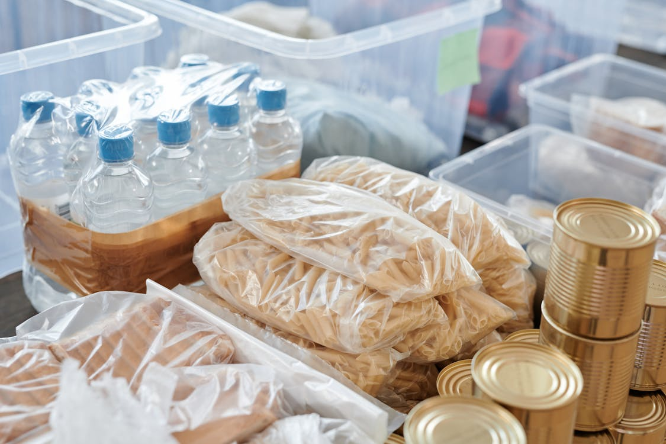
Photo by Julia M Cameron, free license from Pexels

Paper and Cardboard: A Sustainable Solution?
Paper and cardboard are widely regarded as more environmentally friendly options for food packaging, largely because they are biodegradable and easier to recycle than plastic. These materials are commonly used for items like cereal boxes, sandwich wraps, and takeaway containers. Common examples include pizza boxes, egg cartons, and bakery boxes for cakes or pastries.
However, paper packaging has its own environmental costs. The production process often involves deforestation, high water usage, and significant energy consumption. Additionally, paper packaging is sometimes coated with plastic or wax to make it moisture-resistant, which can make recycling more challenging. For example, coffee cups lined with polyethylene are typically discarded after a single use, despite appearing eco-friendly.
Consumers can prioritize certified sustainable products, such as those made from recycled certified paper, to minimize their environmental impact.

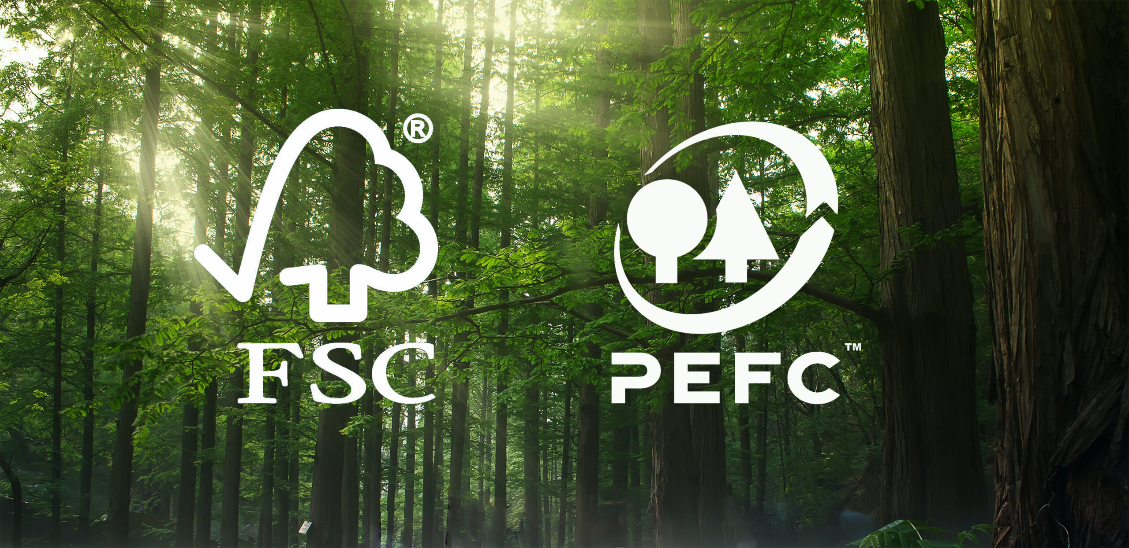

Glass: A Durable but Heavy Choice
Glass packaging is one of the oldest and most durable materials used for food and beverage storage. Its advantages include being fully recyclable without loss of quality and its inert nature, which ensures that no harmful chemicals leach into the food. Glass is commonly used for products like jars of jam, bottles of wine, and sauces. Specific examples include olive oil bottles, honey jars, and glass milk bottles that are increasingly being used by local dairy brands promoting refillable, retournable and reusable systems.
Despite its benefits, glass has limitations. Its production requires high amounts of energy, and its weight increases transportation emissions. While glass can be reused, the infrastructure to facilitate this, such as deposit-return systems, is not universally available in the EU. Consumers can contribute by supporting local businesses that offer refillable glass containers or participating in return schemes where available.

Metal: The Recyclable Contender
Metal packaging, particularly aluminum and tin, is a popular choice for canned goods, beverages, and certain snack products. Metal is highly recyclable, and its recycling process requires significantly less energy than producing new material. Examples include canned vegetables and beans, tuna cans, soda cans, and resealable metal tins for specialty teas or snacks.
However, mining and refining the raw materials used in metal packaging have substantial environmental impacts, including habitat destruction and high energy consumption. Additionally, certain types of metal packaging, such as those with plastic linings, are harder to recycle. Consumers can contribute to reducing waste by opting for products in 100% recyclable metal containers and ensuring proper disposal.

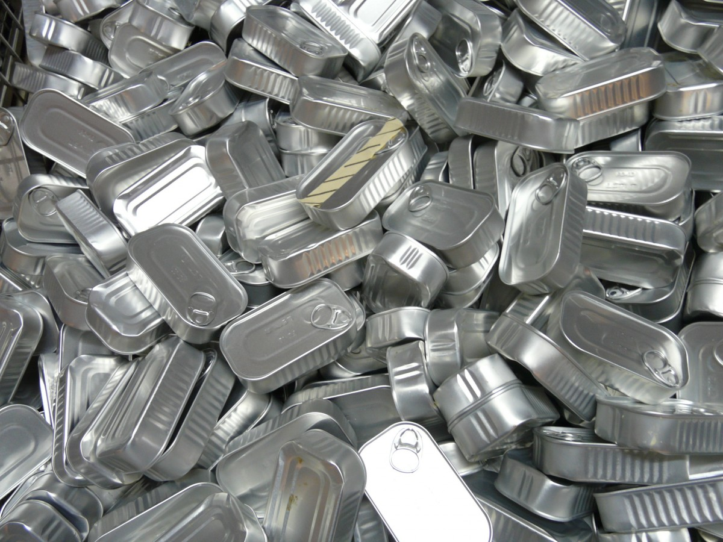
Photo by PH, licensed under CC0 Public Domain

Biodegradable and Compostable Packaging: The Emerging Trend
In recent years, biodegradable and compostable packaging has gained popularity as an eco-friendly alternative to traditional materials. Made from renewable resources like cornstarch, sugarcane, or even seaweed, these materials are designed to break down naturally, reducing their environmental footprint. Examples include compostable coffee pods, plant-based cling wraps, and takeaway containers made from bagasse, a sugarcane byproduct.
However, not all biodegradable packaging is created equal. Some materials require industrial composting facilities to degrade properly and may not decompose in natural environments. Additionally, the production of these materials often competes with food crops for land and resources. Consumers should look for certifications indicating that the packaging is truly compostable and support brands that provide clear disposal instructions.

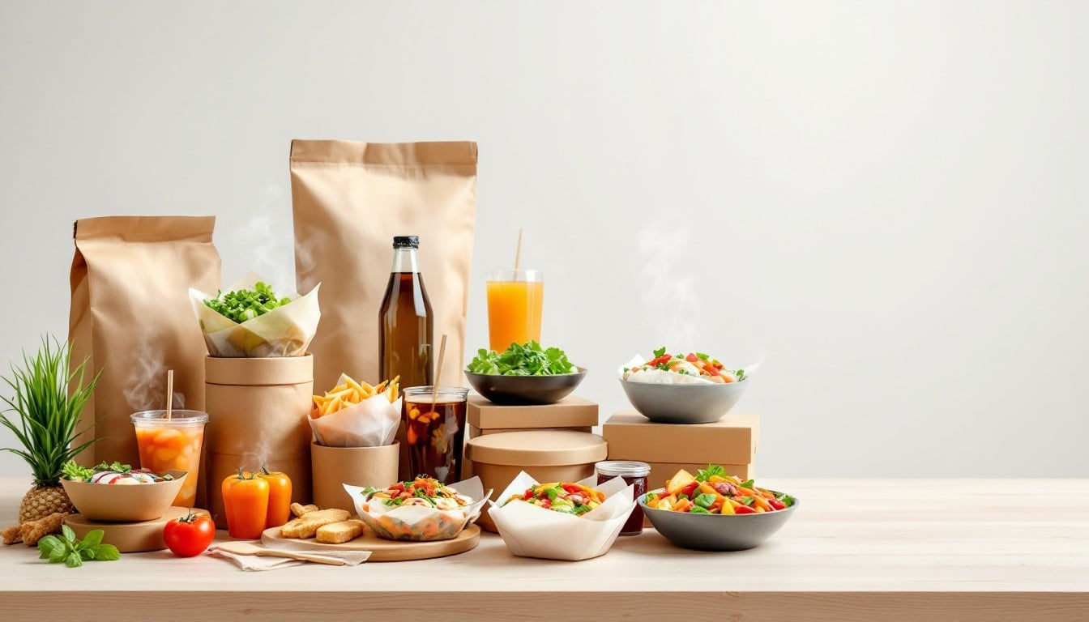
Photo by <a href=”https://stockcake.com/i/sustainable-takeout-spread_1533927_1174176″>Stockcake</a>

The Role of the Magno Project in Driving Change
The Magno Project aims to bridge the gap between innovation and consumer understanding by promoting sustainable packaging solutions across the EU. By collaborating with industries, policymakers, and consumers, the project fosters the adoption of better policy, business and consumer habits and systems that align with the principles of the circular economy. It also emphasizes education, helping consumers identify and choose sustainable packaging options.
For example, the project has highlighted success stories like the widespread adoption of paper-based packaging in the bakery sector, where uncoated, recyclable paper has replaced plastic wraps for bread and pastries. Similarly, it has supported initiatives for reusable glass containers in dairy products, where consumers can return bottles for cleaning and refilling, significantly reducing waste.

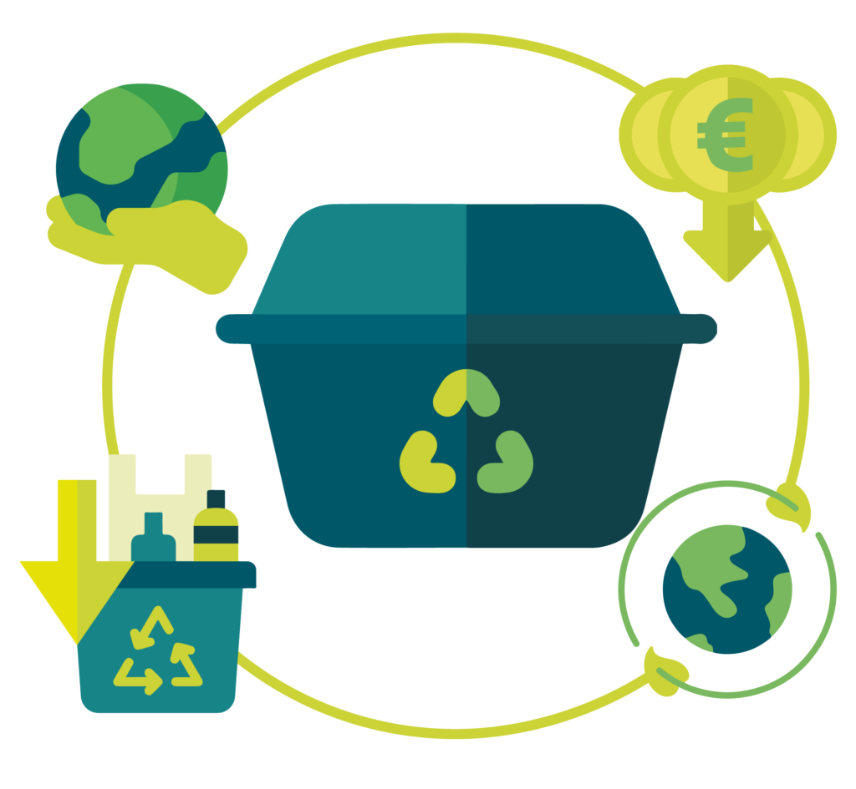

Empowering Consumers to Make Sustainable Choices
Understanding the environmental implications of different packaging materials enables consumers to make informed choices that align with sustainability goals set and required to facilitate the transition towards a more sustainable model. By reducing reliance on single-use plastics, supporting refillable or reusable systems, and properly sorting recyclable materials, consumers can drive demand for environmentally respectful practices.
Initiatives like the Magno Project provide a framework for systemic change, but the role of individuals is equally important. Every decision made at the supermarket or while dining out contributes to shaping a market that prioritizes sustainability. Together, businesses and consumers have the power to redefine food packaging for a healthier planet.

