Plastics have revolutionized food packaging by offering durability, lightweight convenience, and cost efficiency. However, they have also become a significant contributor to global waste, particularly because not all plastics are created equal in terms of recyclability. Understanding the common types of plastics used in food packaging and their recycling labels can empower consumers to make more sustainable choices and properly dispose of waste.
We, as the Magno Project, an initiative promoting sustainable packaging practices, emphasize the importance of consumer education in tackling the plastic waste crisis. By recognizing the materials and labels associated with food packaging, we expect consumers can actively support recycling efforts and reduce the environmental burden of plastic waste. To do so, in this article we want to put the focus on each of the most used plastics and their symbols to facilitate consumers to buy the ones with the most environmental added value.

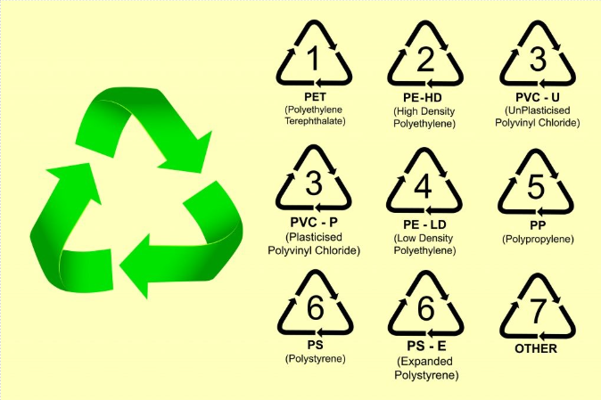

PET (Polyethylene Terephthalate)
PET is one of the most widely used plastics in food packaging. It is lightweight, strong, and transparent, making it ideal for products that require visibility and protection against moisture and air. Common applications include water bottles, soda bottles, salad containers, and jars for condiments such as peanut butter. PET is marked with the recycling code #1, which indicates that it is widely recyclable in most recycling systems.
Recycled PET, or rPET, is increasingly being used to produce new food and beverage containers, textiles, and packaging materials. Despite its recyclability, proper disposal is essential to ensure that PET does not end up in landfills or as litter. In the current systems, consumers can play a vital role by cleaning and sorting PET products before recycling to prevent contamination.

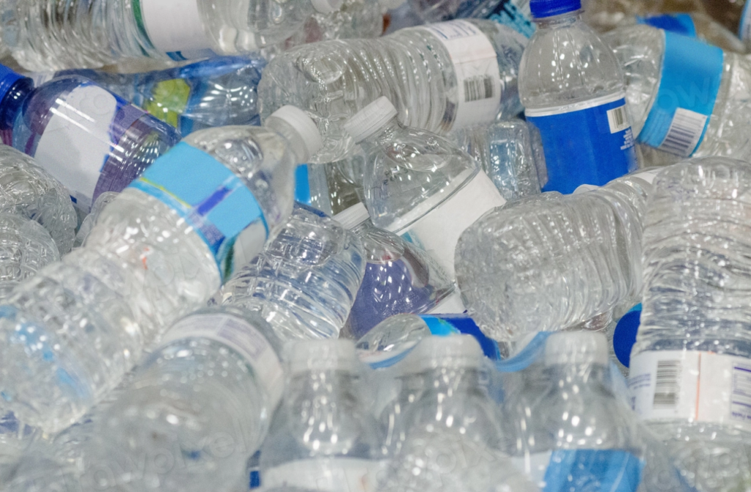
Photograph: via rawpixel (Public Domain)

HDPE (High-Density Polyethylene)
HDPE is known for its rigidity and resistance to chemicals, making it suitable for a wide range of food packaging applications. Milk jugs, juice bottles, yogurt tubs, and containers for household products like cleaning supplies are typically made from HDPE. It is labeled with the recycling code #2, signifying that it is highly recyclable.
This type of plastic is often recycled into new containers, plastic lumber, and pipes. HDPE’s durability and recyclability make it one of the more environmentally friendly plastics, provided it is disposed of correctly. Choosing products packaged in HDPE and supporting brands that use recycled HDPE can further enhance its sustainability.

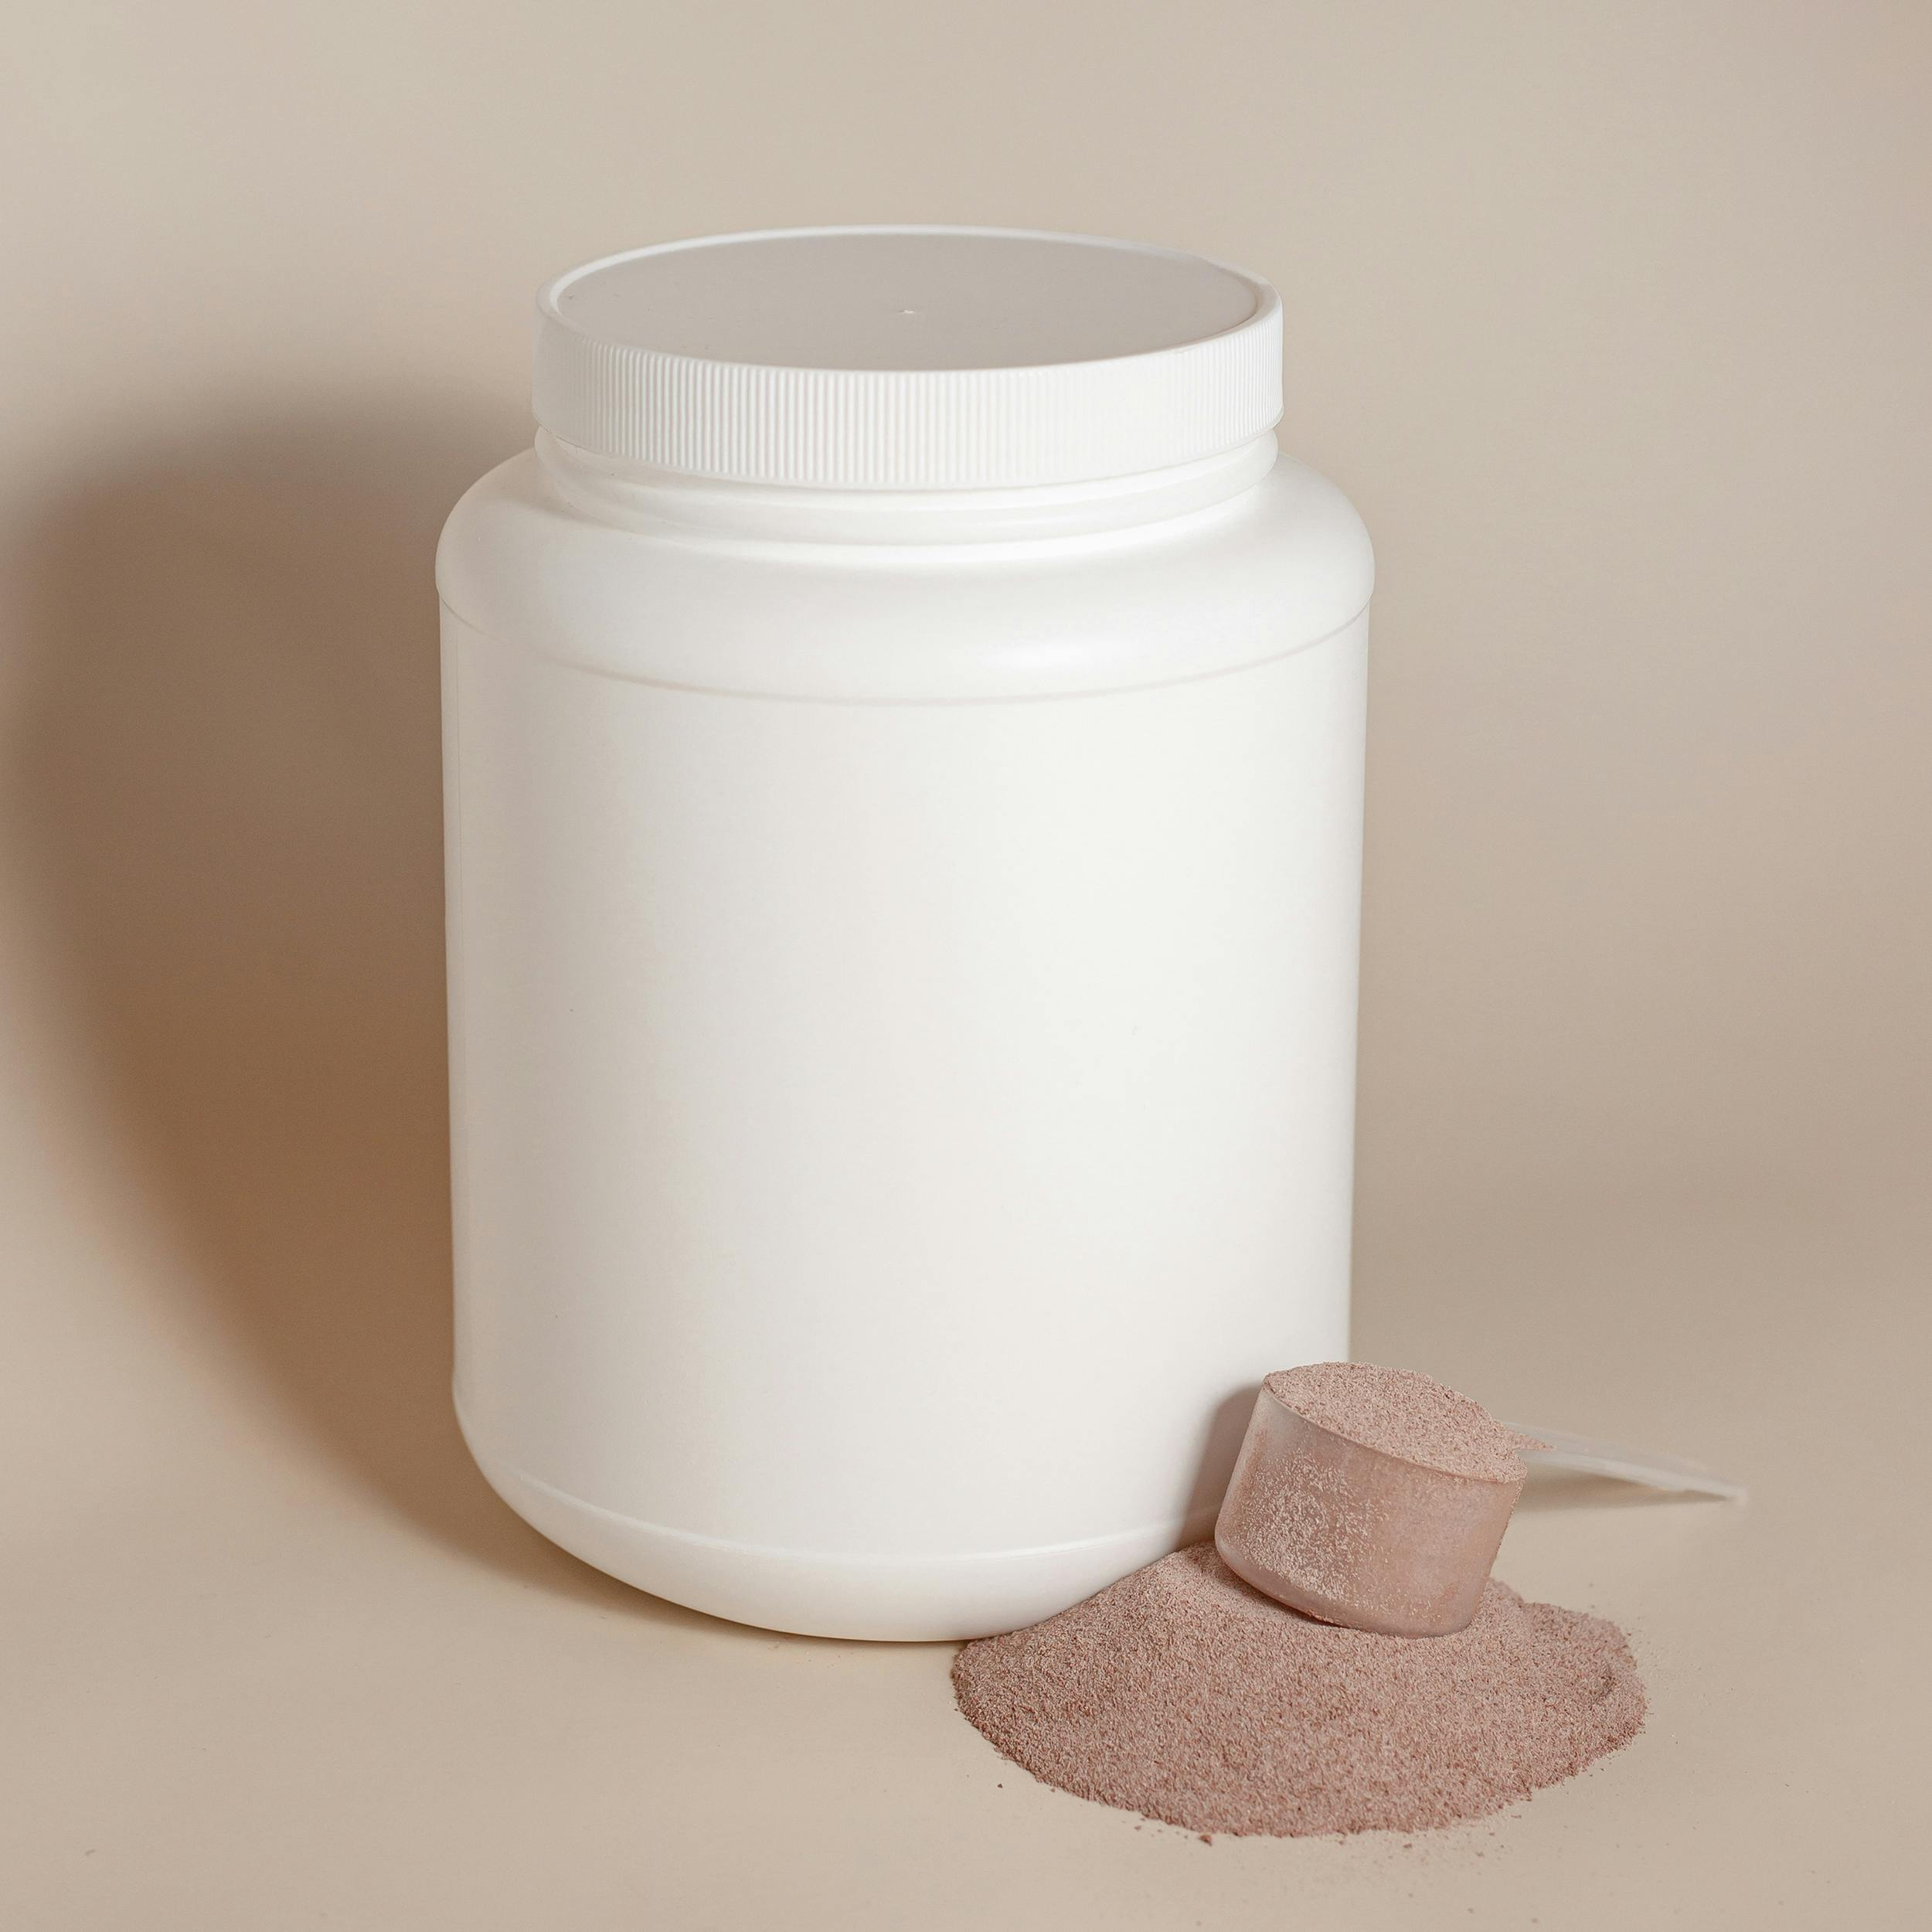
Photo by Supplements On Demand, free license from Pexels

LDPE (Low-Density Polyethylene)
LDPE is a flexible and lightweight plastic commonly used for items like plastic bags, cling film, and squeezable bottles for sauces and condiments. Its versatility has made it a staple in food packaging, especially for items that require flexibility and moisture resistance. LDPE carries the recycling code #4, but its recyclability depends on local facilities, as many regions do not accept it in curbside recycling programs.
Unfortunately, LDPE is often disposed of improperly, contributing significantly to environmental pollution. Consumers can reduce their impact by reusing plastic bags and opting for products with alternative packaging, such as paper wraps or reusable containers, whenever possible.


Photo from Wikipedia Commons, licensed under CC BY-SA 4.0

PP (Polypropylene)
Polypropylene is another common plastic in food packaging, valued for its toughness and resistance to heat. It is frequently used for yogurt cups, microwavable meal trays, bottle caps, and resealable food containers. PP is identified with the recycling code #5, and while it is recyclable, its acceptance varies depending on regional recycling programs.
Recycled PP is often used to manufacture automotive parts, textiles, and industrial products. Consumers can look for products labeled as made from recycled PP or seek out reusable polypropylene containers to minimize waste.


Photo from Wikipedia Commons, licensed under CC BY-SA 3.0

PS (Polystyrene)
Polystyrene, often recognized in its expanded form as Styrofoam, is used for disposable cups, plates, meat trays, and takeaway containers. It is marked with the recycling code #6, but its recyclability is extremely limited due to its low value and the challenges associated with processing it.
PS poses significant environmental risks as it is lightweight and easily breaks into microplastic particles. Consumers are encouraged to avoid products packaged in PS and instead choose items packaged in materials with higher recyclability, such as paper or aluminum.

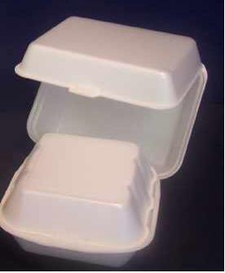
Photo from Wikipedia Commons, licensed under CC BY-SA 3.0

Other Plastics (Including Multi-Layer Plastics)
Plastics that do not fit into the above categories are often labeled with the recycling code #7. This category includes polycarbonate and multi-layer plastics used for products like squeeze pouches, baby food containers, and certain beverage bottles. Multi-layer plastics combine different types of plastics to improve functionality, but they are nearly impossible to recycle because separating the layers is technically challenging.
These plastics often end up in landfills or as environmental litter. As an alternative, consumers can seek out products packaged in simpler, more recyclable materials and support companies that prioritize sustainable packaging.
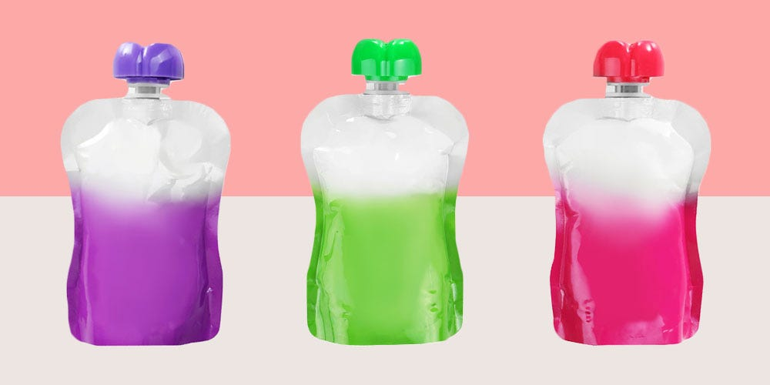
Photo from Shutterstock/Betsy Farrell

Understanding Recycling Labels and Their Significance
Consumers have lesser power than producers and businesses when fixing recycling relations. However, recycling labels are essential for guiding consumers in the proper disposal of plastic waste in order to involve all stakeholder as part of the solution. Each plastic resin code, represented by a number within a triangle of arrows, indicates the type of plastic used and its recyclability. However, these symbols can be misleading, as not all plastics marked with recycling codes are accepted by local recycling facilities.
For example, while PET (#1) and HDPE (#2) are widely recyclable, others like LDPE (#4) and PS (#6) often require specialized facilities. Additionally, even recyclable plastics can be rendered non-recyclable if contaminated with food residue or mixed with non-recyclable materials. This highlights the importance of proper sorting, cleaning, and understanding local recycling guidelines.This is key for consumers to do their part. Now, the ball would be on the business side.

