Every day, all human beings make purchases, and with each purchase, we have the power to help change this situation. An informed consumer makes better decisions, and by making those decisions, we can create a positive impact on the environment and encourage more sustainable practices.

How to Identify Biodegradable or Compostable Packaging
As the need for sustainable packaging increases, many consumers encounter products labeled as “biodegradable” or “compostable” confusing. These terms are often used interchangeably, but understanding the key differences between them can help you make informed choices for both purchasing and disposal.

Before we start keep in mind that:
All compostable products are biodegradable, but not all biodegradable products are compostable
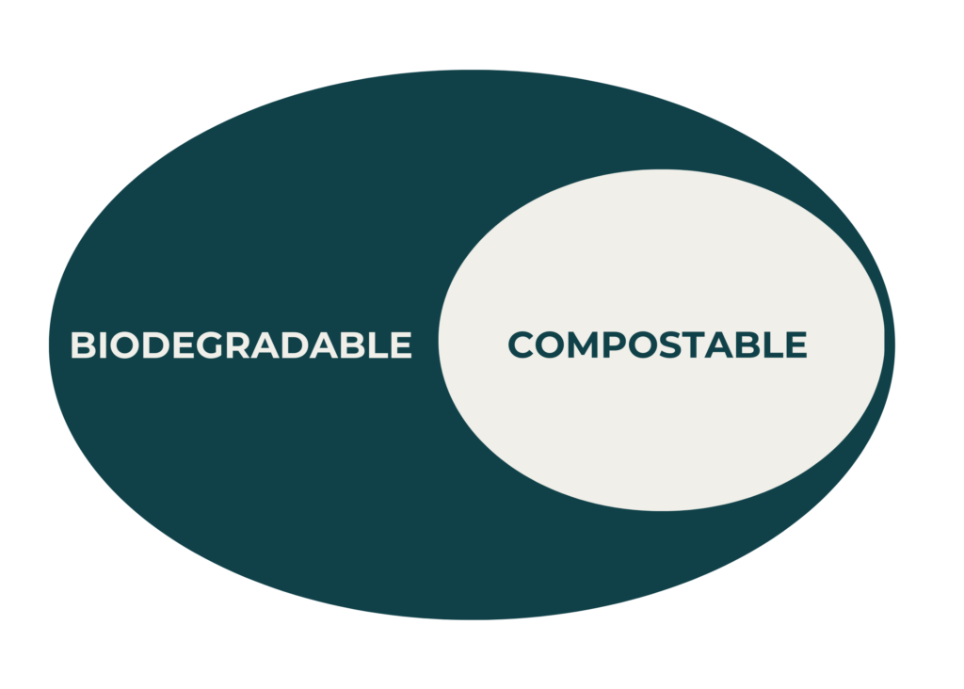

Compostable vs. Biodegradable: What’s the Difference?
Compostable Packaging refers to materials that break down fully into natural elements (such as water, carbon dioxide, and biomass) when exposed to composting conditions. Compostable packaging should decompose at a rate comparable to other organic materials and leave no toxic residues. Products that are compostable must undergo stringent testing under standards ensuring they break down within 90 days without harming plant life. Compostable materials enrich the soil, transforming into nutrient-rich compost that contributes positively to the ecosystem.
On the other hand, Biodegradable Packaging can break down through the action of microorganisms like bacteria and fungi. However, the process of biodegradation may take years, even centuries. The term “biodegradable” is less regulated and does not guarantee that the material breaks down in a timely or safe manner. Without proper standards, biodegradable packaging may still release harmful toxins into the environment, leading to contamination.

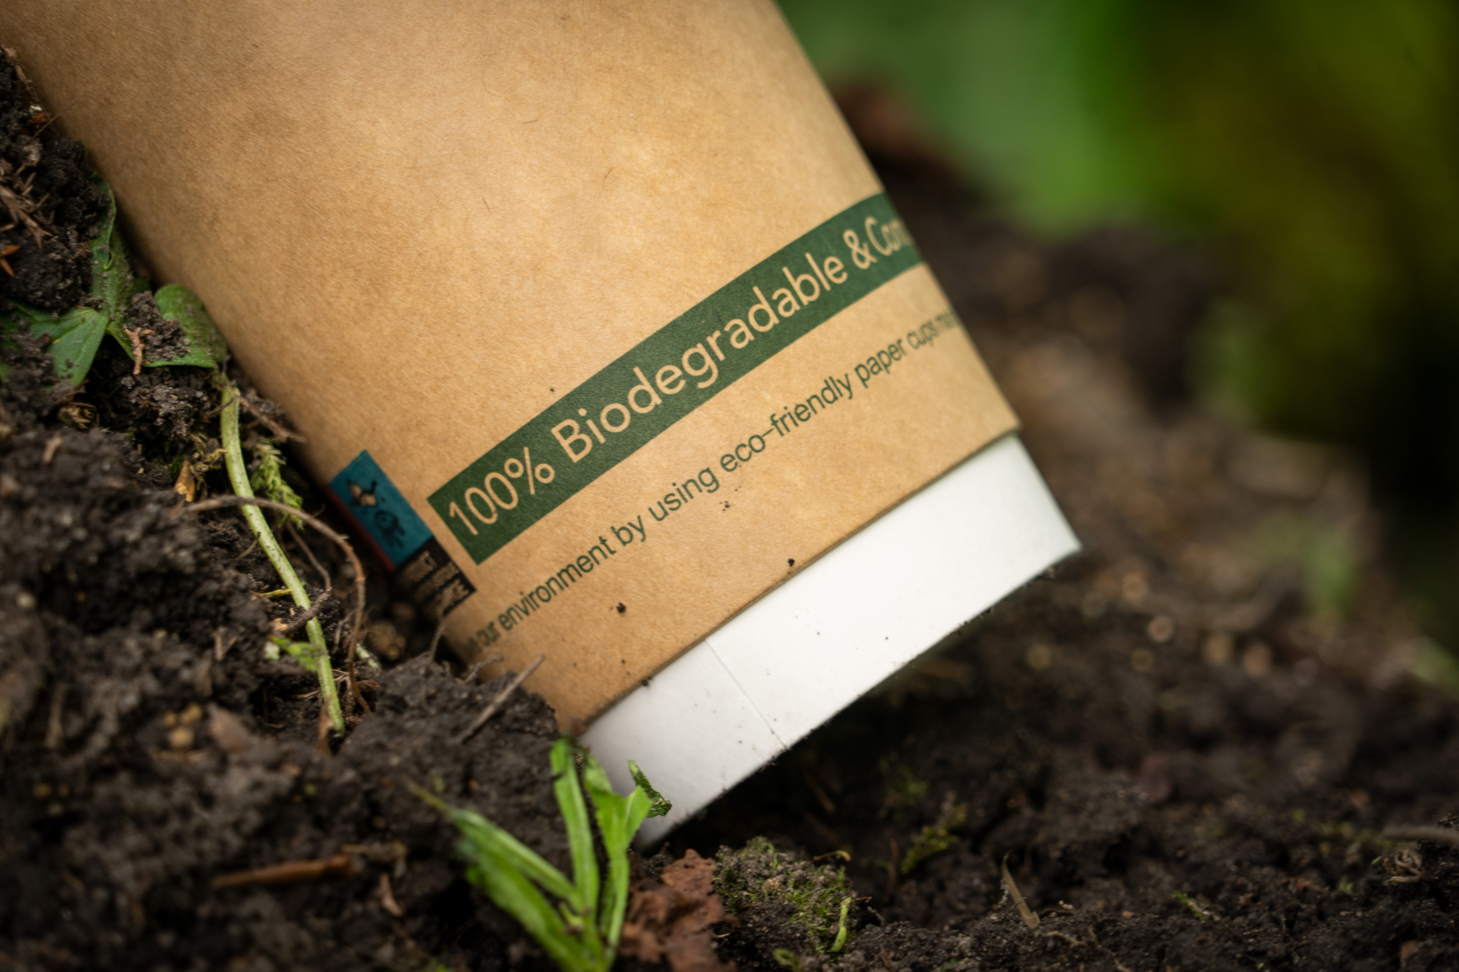
Photo by Wikimedia Commons, licensed under CC BY 2.0

How to Know If My Packaging is Compostable or Biodegradable
Biodegradable plastic bags usually have a soft, slightly “soggy” texture and are made from materials such as corn starch, potato starch, or polyester. To identify whether a bag meets the right standards, check for the EN 13432:2002 mark, along with the phrase “Biodegradable product complying with EU legislation EN 13432,” which is typically printed on the side or front.
You can also look for logos like “OK Compost” or “Compostable,” which are accompanied by a code that ensures traceability to the manufacturer. (Design Gang Studio, n.d.)

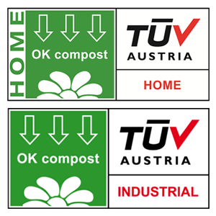

But also keep in mind that the ban does not apply to polyethylene bags commonly used for fruits and vegetables in grocery stores, as they are classified as “protective” bags, not “take-away” bags.

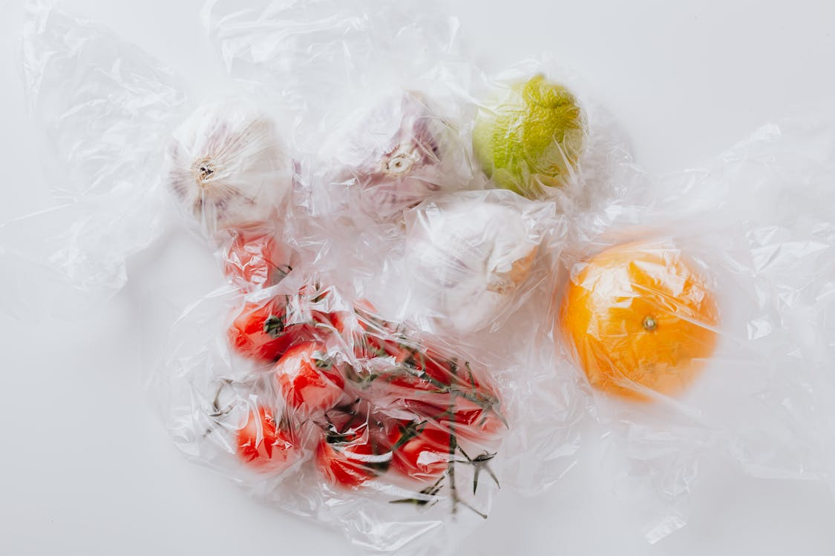
Photo by Kaboompics.com, licensed under CC0

While compostable and biodegradable packaging is a step in the right direction, we believe there is still room for improvement. The efficiency of these materials depends on proper conditions, and many still contribute to waste if not managed correctly.
At MAGNO we think there needs to be more transparency regarding packaging information. Consumers should be able to easily understand the true environmental impact of what they buy to make better-informed, truly sustainable choices.

With this article, we conclude the second section (“Understanding the basics of packaging”) of our consumer awareness campaign, which aims to support consumers on making concious purchasing decisions. Share this article if you found it interesting and if you want to help us in our goal of educating the public about such an important issue.

