The Circular Economy and Its Impact on Food Packaging in the EU
Every day, often without noticing, we, as consumers, interact with food packaging dozens of times — from grabbing yogurt at breakfast to ordering lunch delivery or picking up dinner from the store. Packaging is designed to be convenient and disposable, but its environmental consequences are anything but invisible. The hidden cost of this throwaway culture is mounting — and the need to rethink it has never been more urgent.
Packaging is a major source of plastic waste in Europe, making up nearly 40% of total plastic use. While its convenience and role in food safety are undisputed, the environmental cost is becoming harder to ignore. From overflowing landfills to the rising presence of microplastics in soil and oceans, it’s clear that our current “take-make-dispose” model is unsustainable. (Nearly 40 Percent of Plastic Demand Comes From the Production of Plastic Packaging, 2023)
(Nearly 40 Percent of Plastic Demand Comes From the Production of Plastic Packaging, 2023)
This is where the circular economy comes in. Instead of designing products for short-term use and long-term waste, the circular model prioritizes durability, reuse, recyclability, and regeneration. In food packaging, this shift could mean radically rethinking how we deliver, store, and consume products.
If you’re unfamiliar with the basics of the circular economy, we encourage you to first check out our previous article — What Is the Circular Economy? — for a more detailed introduction to the core principles and ideas.

Real-World Impact of Going Circular
But now let’s talk about what really matters: What would be the real impact of implementing a circular economy in our society? Let’s take a look at each of the benefits. Starting with the most obvious one — the environmental one.

Environmental Benefits: Emissions Reduction and Biodiversity Protection
On the climate front, the circular economy is a powerful tool for emissions reduction. By decreasing the demand for virgin material production and lowering energy consumption, circular packaging models contribute to significant reductions in greenhouse gas emissions. A study by Zambujal-Oliveira and Fernandes (2023) indicates that sustainable packaging practices in the food supply chain can mitigate carbon emissions, aligning with global climate objectives (Zambujal‐Oliveira & Fernandes, 2024).
Moreover, by minimizing raw material extraction and waste generation, circular practices help protect ecosystems from degradation. This reduces pressure on natural habitats and contributes to biodiversity preservation by limiting land-use change, pollution, and resource depletion — key drivers of species loss. (Circular Economy: Definition, Importance and Benefits | Topics | European Parliament, n.d.)

Photo by Owen.outdoors (Pexels), licensed under CC0

Reducing Dependency on Raw Material Imports
In 2022, each European consumed approximately 14.9 tonnes of raw materials, with the EU exhibiting a 69.7% dependency on imported fossil energy carriers and a 51.5% dependency on metal ores. This reliance poses risks related to supply volatility and price instability. Implementing circular economy strategies, such as recycling and reuse, can mitigate these risks by keeping valuable materials in use and reducing the need for imports. («SDG 12 – Responsible Consumption And Production», 2025)

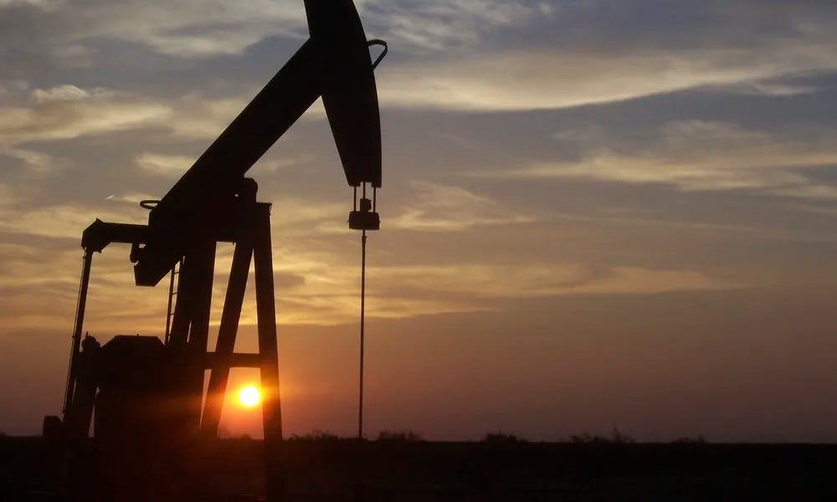
Photo by rawpixel.com, licensed under CC0 1.0

Enhancing Supply Chain Resilience
Closely related to the above, circular economy practices contribute to more resilient supply chains by reducing reliance on finite resources and minimizing exposure to global market shocks. By fostering local sourcing and promoting the use of secondary materials, businesses can achieve greater stability and predictability in their supply chains.

Cost Savings and Business Efficiency
If what we’re interested in are the economic benefits for businesses, it’s also important to know that adopting circular economy principles can lead to significant cost savings for businesses. For instance, reducing packaging waste and improving recycling processes can decrease production costs and enhance operational efficiency. Additionally, businesses that embrace circular models often gain reputational benefits and are better positioned to comply with emerging regulatory pressures.

Economic Growth and Job Creation
But beyond the environmental aspect and the economic benefits for businesses, the circular economy also brings social benefits for us as individuals. Implementing this model has the potential to boost the EU’s GDP by an additional 0.5% by 2030. This growth is attributed to increased competitiveness, innovation, and the development of new business models. Furthermore, the transition is expected to create approximately 700,000 new jobs across the EU by 2030, particularly in sectors like recycling, repair, and product redesign. (Circular Economy: Definition, Importance and Benefits | Topics | European Parliament, n.d.)

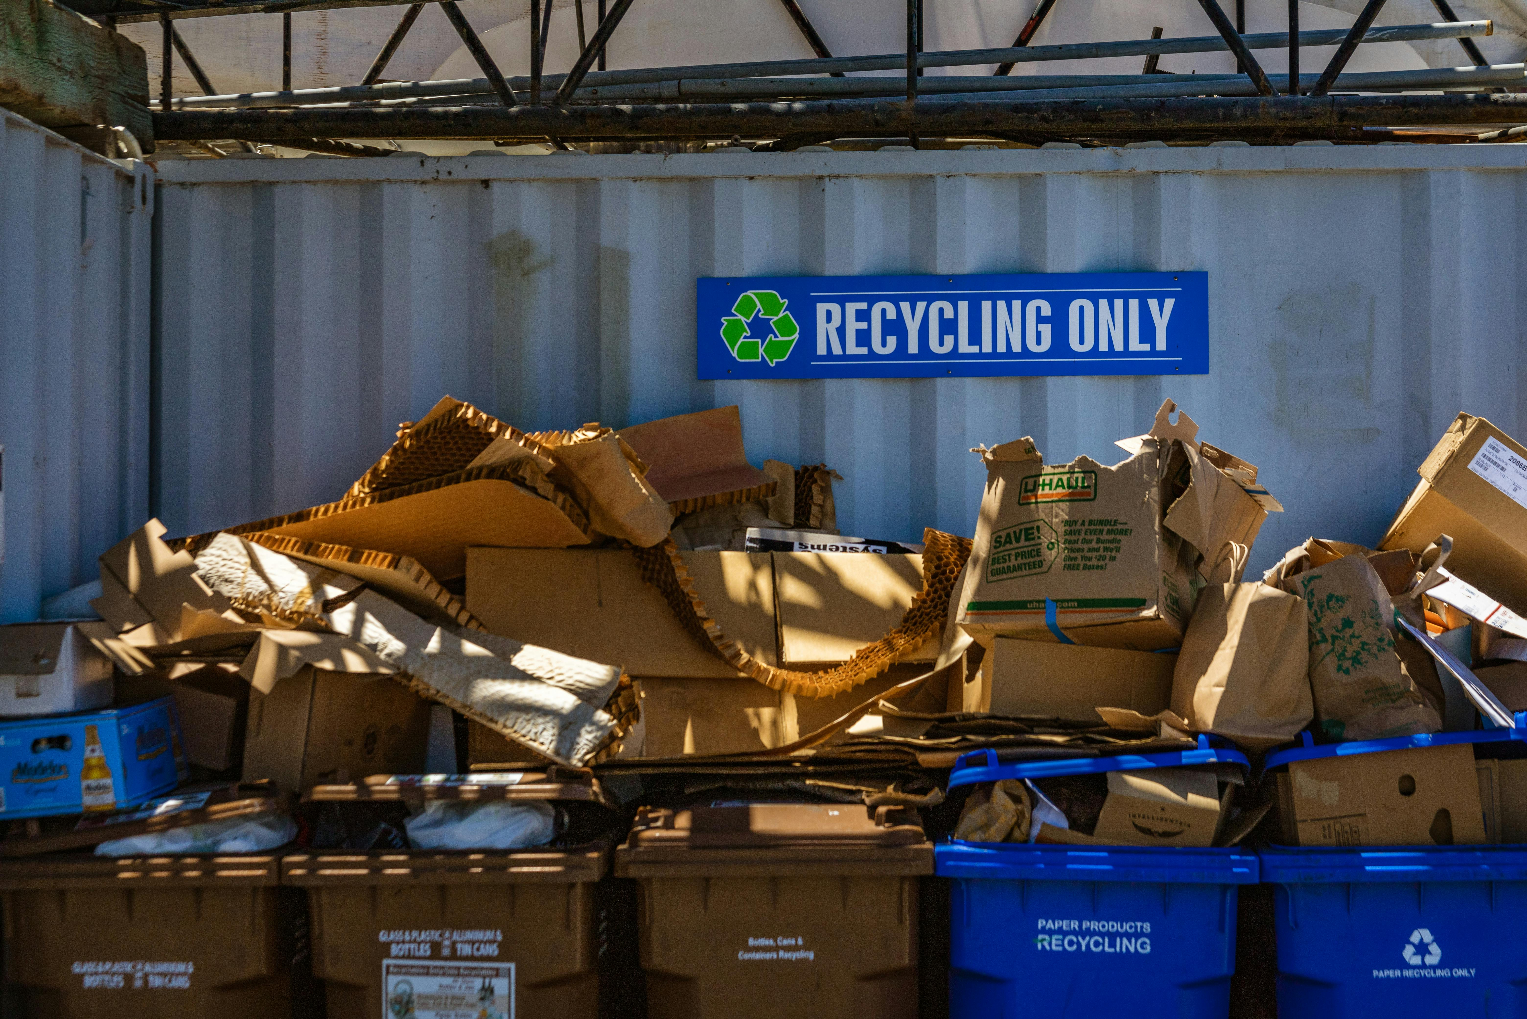
Photo by Robert So (Pexels), licensed under CC0

All in all, the real-world impact of implementing a circular economy is far-reaching — from reducing emissions and conserving resources to boosting economic resilience and social well-being. These benefits are not abstract; they translate into concrete improvements in how we produce, consume, and live. One of the clearest areas where this transformation can be seen — and urgently needed — is food packaging. Let’s explore how a circular approach is reshaping this everyday essential.

A New Vision for Food Packaging
Rather than starting from scratch every time we open a new container or unwrap a snack, the circular approach imagines a system where packaging has a lifecycle beyond its initial use. This includes refillable containers, bulk purchase systems, monomaterial packaging that can be easily recycled, and compostable options for harder-to-recycle formats.
By implementing these solutions, food packaging can become part of a closed-loop system where waste is minimized, and value is retained. Some businesses are already piloting refill stations and reusable delivery systems. The growing availability of these alternatives proves that a more circular food packaging system isn’t just aspirational — it’s happening now.

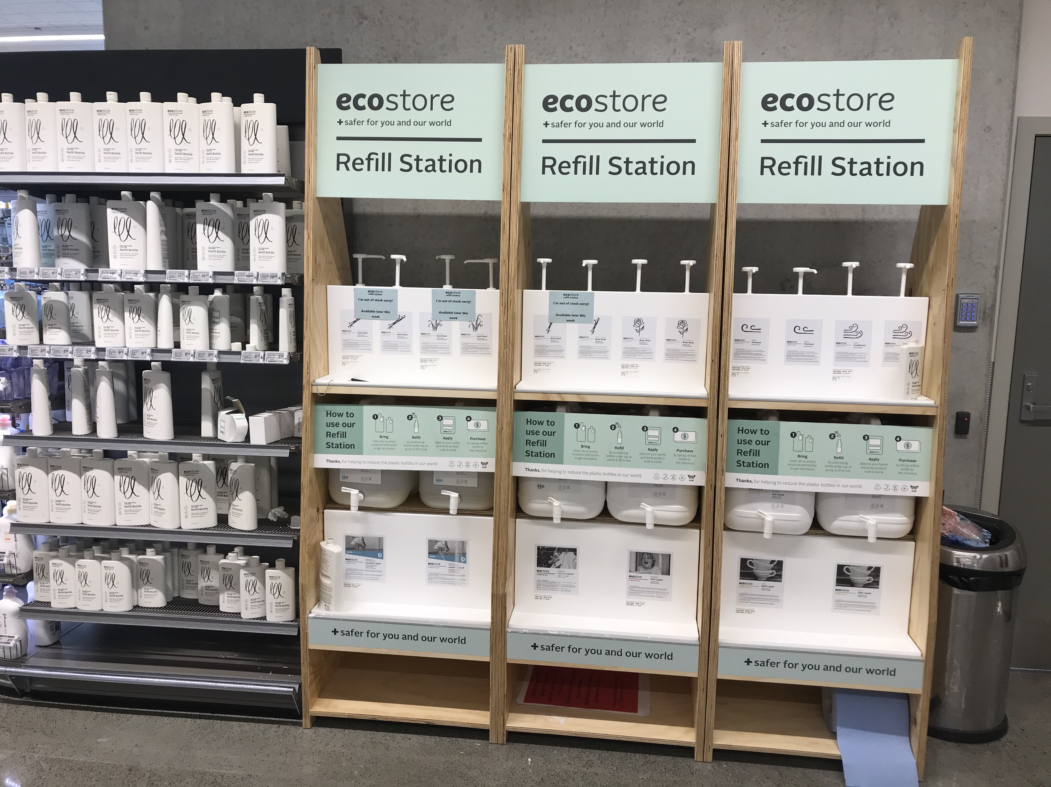
Photo by Wikimedia Commons, licensed under CC BY-SA 4.0

What is the EU doing about it? Regulation and Action
The European Union has taken concrete steps to make this shift a reality. The Packaging and Packaging Waste Regulation (PPWR), adopted in 2025, requires that all packaging in the EU be recyclable or reusable by 2030. The regulation also establishes mandatory recycled content targets and sets a path to reduce unnecessary packaging volume. (Packaging Waste, 2025)
Notably, the EU is also cracking down on single-use plastic packaging, especially in the hospitality sector. Starting in 2030, the sale of individual plastic sachets for condiments, sauces, and sugar in restaurants and hotels will be banned, alongside single-use plastic packaging for fresh fruits and vegetables. These measures aim to push industry players toward sustainable packaging solutions and reduce the overall environmental burden of food-related waste. (Packaging Waste, 2025)

MAGNO’s Contribution
The MAGNO Project supports this shift by focusing on circular innovation within the food packaging sector. From promoting AI-powered material traceability tools to exploring reusable packaging systems, MAGNO works to make the circular economy not just possible, but practical.
Through collaborative research, awareness campaigns, and policy engagement, MAGNO helps close the loop on food packaging waste and supports the EU’s broader sustainability goals.

Final Thought
What we throw away says a lot about how we live. Food packaging might be small, but its impact is massive — and so is its potential for change. Transitioning to circular systems won’t happen overnight, but it begins with decisions made today: by me and you, by consumers, companies, and policymakers. Redesigning food packaging for a circular economy is not just an environmental priority — it’s a smart, necessary step toward building a future where convenience no longer comes at the cost of the planet.

