Promotion of circular economy for consumers: Benefits and examples of circular practices in packaging
Every day, consumers make dozens of decisions that contribute to environmental impact. One of the most significant—and often overlooked—is related to the packaging of the products we buy. Whether it’s takeaway food, bottled drinks, or supermarket goods, packaging is everywhere. And unfortunately, most of it is still designed for single-use.
The circular economy offers an alternative: a way to transform our consumption habits by promoting smarter, more sustainable systems. But what does this mean for everyday consumers? And what practical packaging solutions already exist to support this shift?

Why Consumer Participation Matters
Consumers are key players in the transition to a circular economy. Their preferences shape production models and influence companies to adopt sustainable practices. When shoppers choose products with recyclable, reusable, or compostable packaging—or opt for refill systems over disposables—they send a clear signal to the market.
Public awareness, however, remains a major hurdle. A 2022 EU survey showed that while most consumers support environmental initiatives, only a small percentage feel informed enough to act effectively (Eurobarometer, 2022). Making circular packaging solutions accessible, affordable, and easy to understand is crucial to bridging that gap.

Real Benefits for Consumers and Society
In our previous article, we explored the full range of benefits and real-world impacts that implementing a circular economy model could bring. If you missed it, we encourage you to take a look here: MAGNO CONSUMER INSIGHTS: The Circular Economy and Its Impact on Food Packaging in the EU – MAGNO-PROJECT
While circular packaging is often discussed in terms of sustainability, its impact goes far beyond that. For consumers, adopting reusable or refillable packaging systems can lead to cost savings and improved convenience. For example, buying products in bulk or using refill stations reduces packaging waste and often lowers the overall price per unit.
Health-wise, shifting to circular packaging makes a lot of sense—many of the newer materials avoid the harmful substances that can leach from traditional plastic and end up in our food. But the impact doesn’t stop at what’s on our plates. Circular models also give local economies a boost by creating opportunities in areas like repair, logistics, and product cleaning. And let’s not forget innovation—businesses are rethinking everything from bottle returns to edible packaging. Most importantly, these changes empower consumers. Instead of just throwing things away, we become part of a system that keeps materials in play and builds stronger, more resilient communities.
But how can this new model actually be applied in the real world? The good news is, we already have examples across Europe that show it’s not only possible, but already happening. Let’s take a look at some of the ways circular economy principles are being put into action through packaging solutions.

Circular Packaging in Practice: Real and Emerging Examples
Here are some concrete examples—both in use and conceptual—that illustrate how circular economy principles are being applied to packaging.
To make this section easier to follow, we’ve ordered the examples from the most familiar (which you might have already encountered) to more innovative, emerging solutions that offer a glimpse into the future of circular packaging.

Refill Stations in Retail Chains (EU-wide)
Retail giants like Carrefour are rolling out refill stations in countries such as France and Spain, allowing customers to bring their own containers to purchase goods like cereals, pasta, and detergents. Similarly, UK-based pilot programs are extending this practice across grocery and household care sectors. These stations not only reduce single-use plastic packaging but also promote more sustainable consumption habits.
Besides environmental benefits, they offer economic incentives: customers often pay less per unit by avoiding branded packaging. The growing popularity of these systems reflects increasing consumer demand for zero-waste options and government-backed initiatives supporting packaging reduction goals. («Universal Registration Document 2024 Annual Financial Report», 2024)

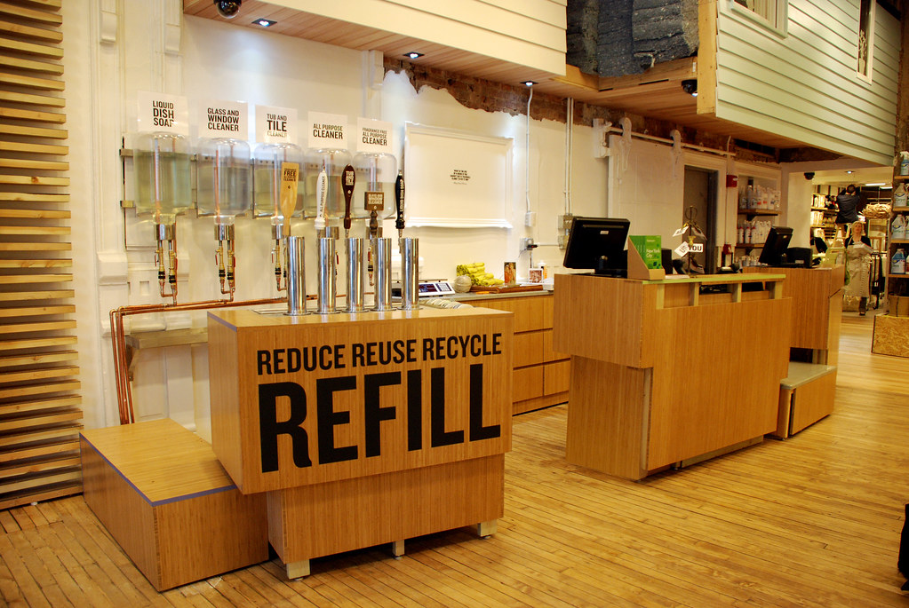
Photo by Dave Pinter (Flickr), licensed under CC BY-NC-ND 2.0

Deposit Return Systems (Denmark)
Denmark’s deposit return system (DRS) is a standout example of how circular models can be scaled nationally. Managed by Dansk Retursystem, the system achieved a record-high return rate of 93% in 2024, collecting more than 2.1 billion bottles and cans. Consumers pay a small deposit when buying bottled drinks and receive it back upon returning the containers. (Strinati, 2025)
This not only keeps valuable materials in circulation but also cuts emissions significantly. In 2021 alone, the system reduced CO₂ emissions by 210,000 tonnes through closed-loop recycling that transforms returned containers into new ones. Beyond environmental savings, the DRS promotes a culture of recycling, with Danes widely engaged from an early age due to its ease and financial incentive. (The Danish Deposit & Return System for Recycling Drink Cans and Bottles | State of Green, 2025)

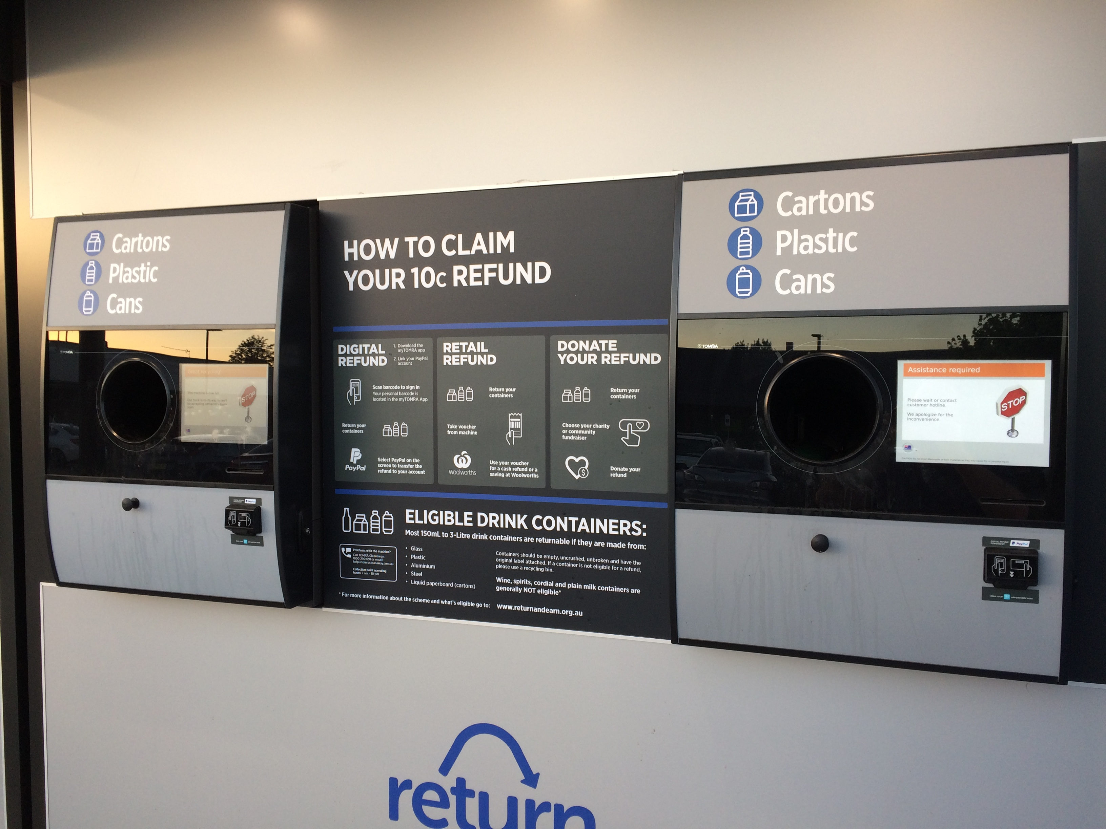
Photo by Wikimedia Commons, licensed under CC BY-SA 3.0

Zero-Waste Supermarkets (France)
The French supermarket chain “Tout Nu” offers a zero-packaging shopping experience where customers bring their own containers or borrow reusable glass jars provided by the store. This model eliminates disposable packaging at the point of sale and incentivizes reuse through a small refund scheme. Each week, the store successfully manages the reuse of around 2,500 food containers (Seas At Risk, 2021).
Beyond reducing plastic waste, “Tout Nu” supports local economies—according to “Le Super Tout Nu”, the zero-waste supermarket that pioneered this model, 60% of its products come from 400 regional producers located within 100 km (The Editor, 2024). The model reflects a shift in consumer values: according to a 2020 survey, 42% of French consumers are willing to pay more for sustainably packaged goods (Statista, 2020). With the zero-waste packaging market in France expected to reach over $14.8 billion by 2030 (Grand View Research, 2023), it’s clear this trend is here to stay.

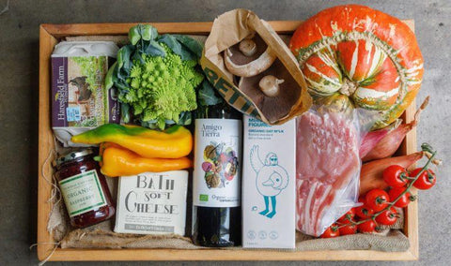
Photo by Bower Collective, licensed under CC BY-NC 4.0

Vegware Compostable Packaging (Scotland)
Vegware is a UK-based company creating plant-based, compostable food packaging from renewable materials like cornstarch, PLA, and bagasse. These products are designed to be composted alongside food waste in industrial composting facilities, breaking down into nutrient-rich compost in under 12 weeks.
In 2021, Vegware’s ‘Close the Loop’ program in Scotland collected over 76 tonnes of used Vegware products for composting—equivalent to 4.4 million cups and lids of approximately 355 ml. The company also helped 55 clients, including offices, universities, and cafes, establish composting schemes. By the end of that year, commercial collection services were available in 46 of the UK’s largest towns and cities, covering nearly half the population (Vegware Sustainability Report, 2021).
This model not only diverts waste from landfills and reduces methane emissions but also returns valuable nutrients to the soil—supporting agriculture and aligning with circular economy principles.

Edible Coffee Cups (Bulgaria)
A creative example of circular innovation from Eastern Europe comes from Bulgaria’s Cupffee, a company producing edible coffee cups made from natural cereals. These cups are biodegradable, compostable, and fully edible, offering an alternative to single-use disposable cups that often end up in landfills. Cupffee’s products can retain their crispness for up to 40 minutes after contact with hot liquids and leave no waste behind. (About Us | Cupffee, n.d.)
This model not only reduces plastic pollution but also promotes a zero-waste culture by rethinking everyday items through a circular lens. It demonstrates how smart design and consumer engagement can create real environmental impact, even in sectors like food packaging.

Eco-Friendly Thermoformed Food Packaging (Spain)
In Spain, the adoption of circular practices in food packaging is gaining momentum through companies specializing in sustainable solutions. One example is the company Arplast that is developing thermoformed containers made from 100% recycled plastics and cardboard, as well as biodegradable and compostable bioplastics.
These materials are used to create customizable, eco-designed packaging that supports both small and large production volumes — making sustainable alternatives more accessible for businesses of different sizes. (Fábrica De Envases Plásticos – Arplast, 2025)
This approach reflects a broader trend toward embedding circularity into food packaging systems at every stage, from material selection to end-of-life disposal.

IFCO Reusable Transport Crates (Germany)
Used extensively in European fresh produce supply chains, IFCO reusable transport crates are engineered to be used over 100 times before being recycled. This durability significantly reduces the need for single-use packaging, cutting down on raw material use and waste generation. A life cycle analysis commissioned by IFCO Group shows that these crates can reduce CO₂ emissions by up to 60% compared to one-way packaging alternatives (Montagnani, 2024)

Smart Packaging Prototypes (Global)
Battery-free packaging with embedded sensors is currently being tested as an innovative approach to extending product shelf life and reducing food waste. These prototypes can monitor freshness indicators such as temperature, humidity, and gas composition — and some may even release natural preservatives when spoilage is detected. Though still in the research phase, such smart packaging solutions could one day become key to more efficient food systems and support circular economy goals by preventing waste before it occurs. (Douaki et al., 2024)

What Is MAGNO Doing About It?
MAGNO is playing a key role in helping make circular packaging a reality by promoting innovation, collaboration, and practical solutions across the value chain. The project is developing a Digital Twin Ecosystem that enables packaging producers and stakeholders to model, track, and optimize packaging lifecycles in real time. In parallel, MAGNO is piloting the use of AI-powered traceability systems to better monitor packaging materials and improve end-of-life outcomes.
But that’s not all, the project supports sustainable packaging design by bringing together stakeholders from industry, academia, and policy to co-create solutions, and to promote new business models based on reuse, return to reduce waste and increase circularity.
Through these efforts, MAGNO aims to empower consumers and industries alike, creating pathways to more sustainable and circular practices in food packaging.

Final Thoughts
But all the examples explained above would never have been possible without a shift in consumer behavior. That’s why our role as individuals is so important. Circular packaging isn’t just an environmental strategy — it’s also a personal one. Every container we reuse, every refill we choose, every wrapper we avoid is a signal to the system that things need to change.
At MAGNO, we believe this transformation starts with people.
Because real transformation doesn’t begin in boardrooms or legislation alone — it begins with us.

