How can consumers contribute to a circular economy in food packaging?
We often hear about circular economy as something industries and governments must lead — and while that’s true, there’s another major player in this transformation: the consumer.
Every time we shop, eat on the go, or store leftovers, we interact with food packaging — and the choices we make in these everyday moments carry real weight. In a system where materials are meant to be reused, recycled, or regenerated, consumer participation isn’t just helpful — it’s essential.
So, what can we actually do to support the circular economy through our daily habits? And how can individual actions shape the future of sustainable food packaging?

The Power of Consumer Choice
In the traditional “take-make-dispose” model, packaging is used once and discarded — often ending up in landfills or the ocean. The circular economy flips that script, designing systems where materials stay in use for as long as possible.
But for these systems to work, they need people.
When consumers choose products with reusable, recyclable, or compostable packaging, or when they return containers, bring their own bags, or avoid unnecessary wrapping, they send a market signal that sustainability matters.
It might seem small, but multiplied across millions of people, these decisions help drive:
- Industry innovation
- Regulatory shifts
- New business models based on reuse and material recovery
According to a 2022 Eurobarometer survey, 90% of Europeans support measures to reduce plastic waste — yet only a fraction feel they have the tools or information to act effectively. That’s why consumer awareness is a key part of the transition: people need to know not just why change matters, but how to take part in it. Eurobarometer: Protecting the Environment and Climate

Practical Ways to Contribute
Circular consumption doesn’t have to be complicated. In fact, it’s often about simplifying — buying smarter, wasting less, and supporting brands that do better.
We also understand a common concern: many sustainable packaging options are still more expensive, and not everyone can afford them. But here’s the good news — circular choices don’t always mean higher costs. In fact, some of the most impactful changes are both eco-friendly and economical.
Here are some accessible ways to support circularity in food packaging — no matter your budget:

1. Choose Refill & Return Systems
More and more stores offer refill stations for dry goods, detergents, and even beverages. Some brands use deposit-return schemes for bottles or jars — rewarding customers for giving packaging a second life. These systems often reduce packaging waste and offer savings over time.
More information: https://www.refill.org.uk/about/what-is-reuse/

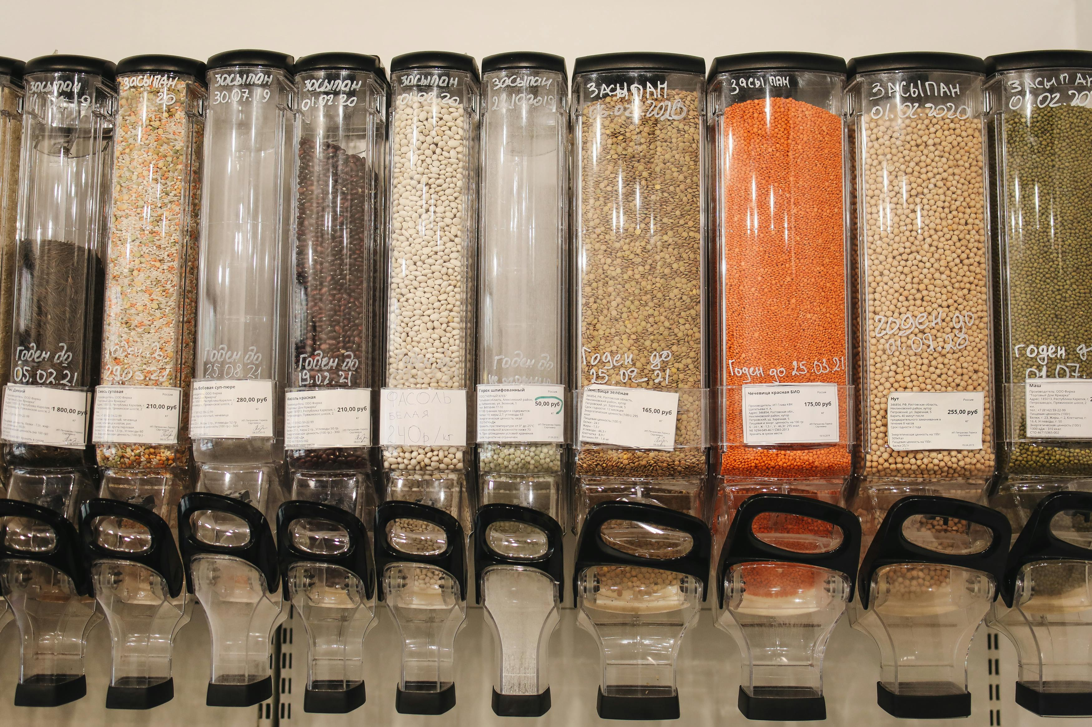
Photo by Polina Tankilevitch (Pexels), licensed under CC0

2. Bring Your Own Containers & Bags
Whether at the supermarket, local bakery, or takeaway spot, bringing your own reusable packaging is a simple, low-cost way to cut single-use waste. Some cafés even offer discounts for customers who bring their own cups.
More information: https://sociallab2018.medium.com/bring-your-own-container-byoc-ffbd697464b2
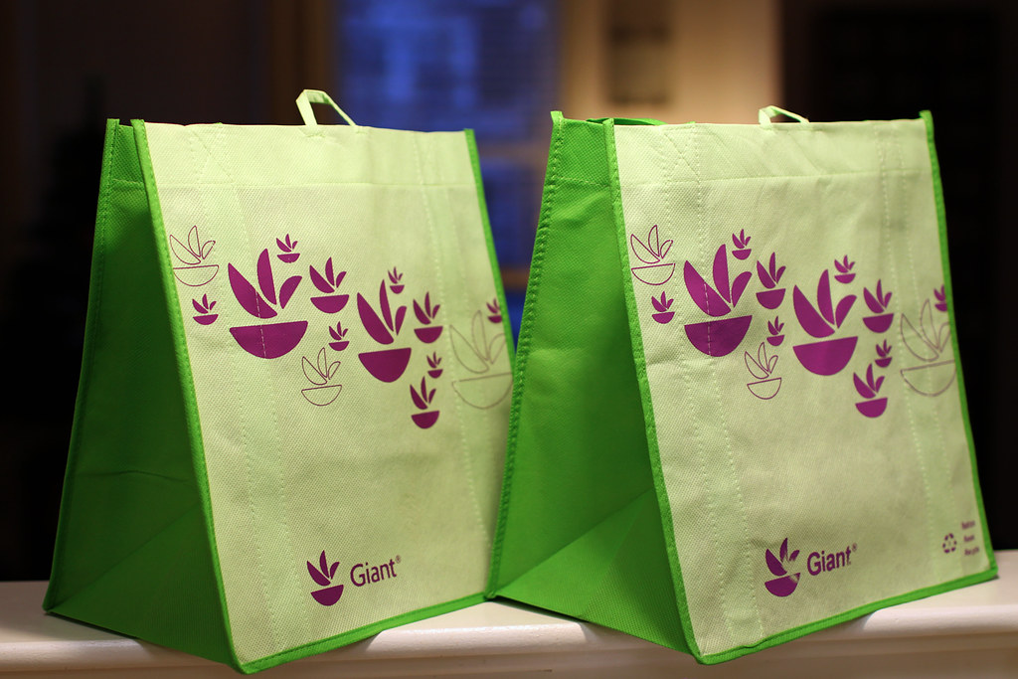
Photo by Mr.TinMD (Flickr), licensed under CC BY-ND 2.0

3. Support Compostable & Edible Packaging
Products that use plant-based, biodegradable materials (or even edible ones) reduce landfill waste and promote innovation. While some of these options may cost more, they also reflect growing consumer demand and are becoming more accessible.
More information: https://plasticsmartcities.org/edible-packaging/

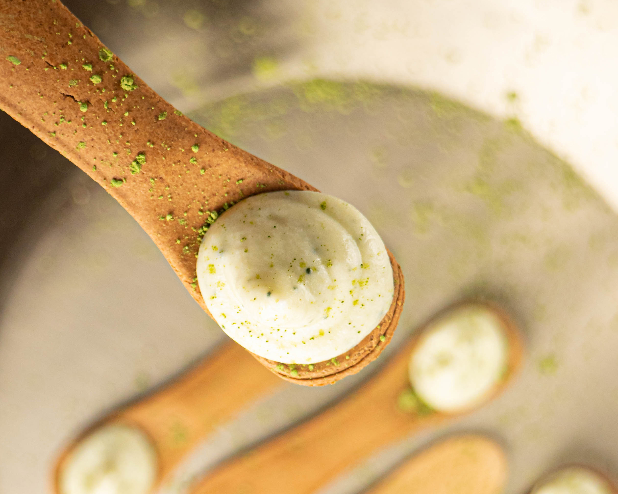
Photo from Wikimedia Commons, licensed under CC BY-SA 4.0

4. Buy in Bulk
This is one of the easiest circular strategies — and it’s often cheaper. Buying in larger quantities reduces the need for individual wrappers or plastic containers, while also lowering the overall price per unit.
More information: https://www.bbc.com/future/article/20240528-buying-groceries-in-bulk-is-better-for-the-planet

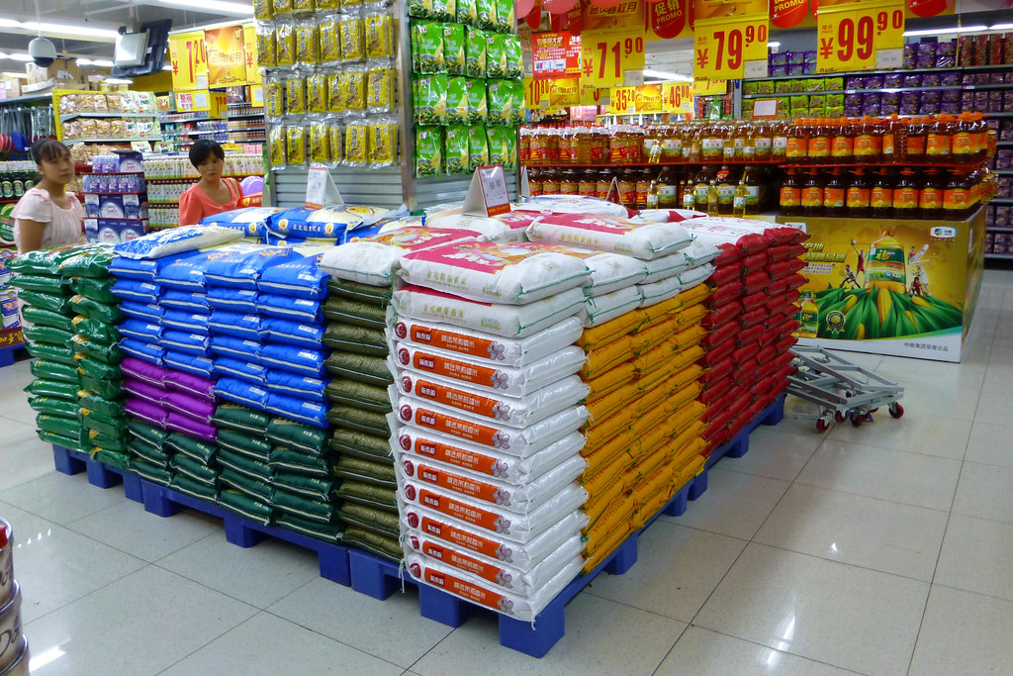
Photo by Chris (Flickr), licensed under CC BY-NC-SA 2.0

5. Recycle Correctly
Recycling is free, but its impact is huge. Understanding what can and can’t be recycled in your area — and making sure items are clean and sorted — helps keep valuable materials in the loop and out of landfills.
More information: https://magno-project.eu/magno-consumers-insights-a-simple-guide-to-understanding-packaging-labels-and-decode-recycling-symbols/

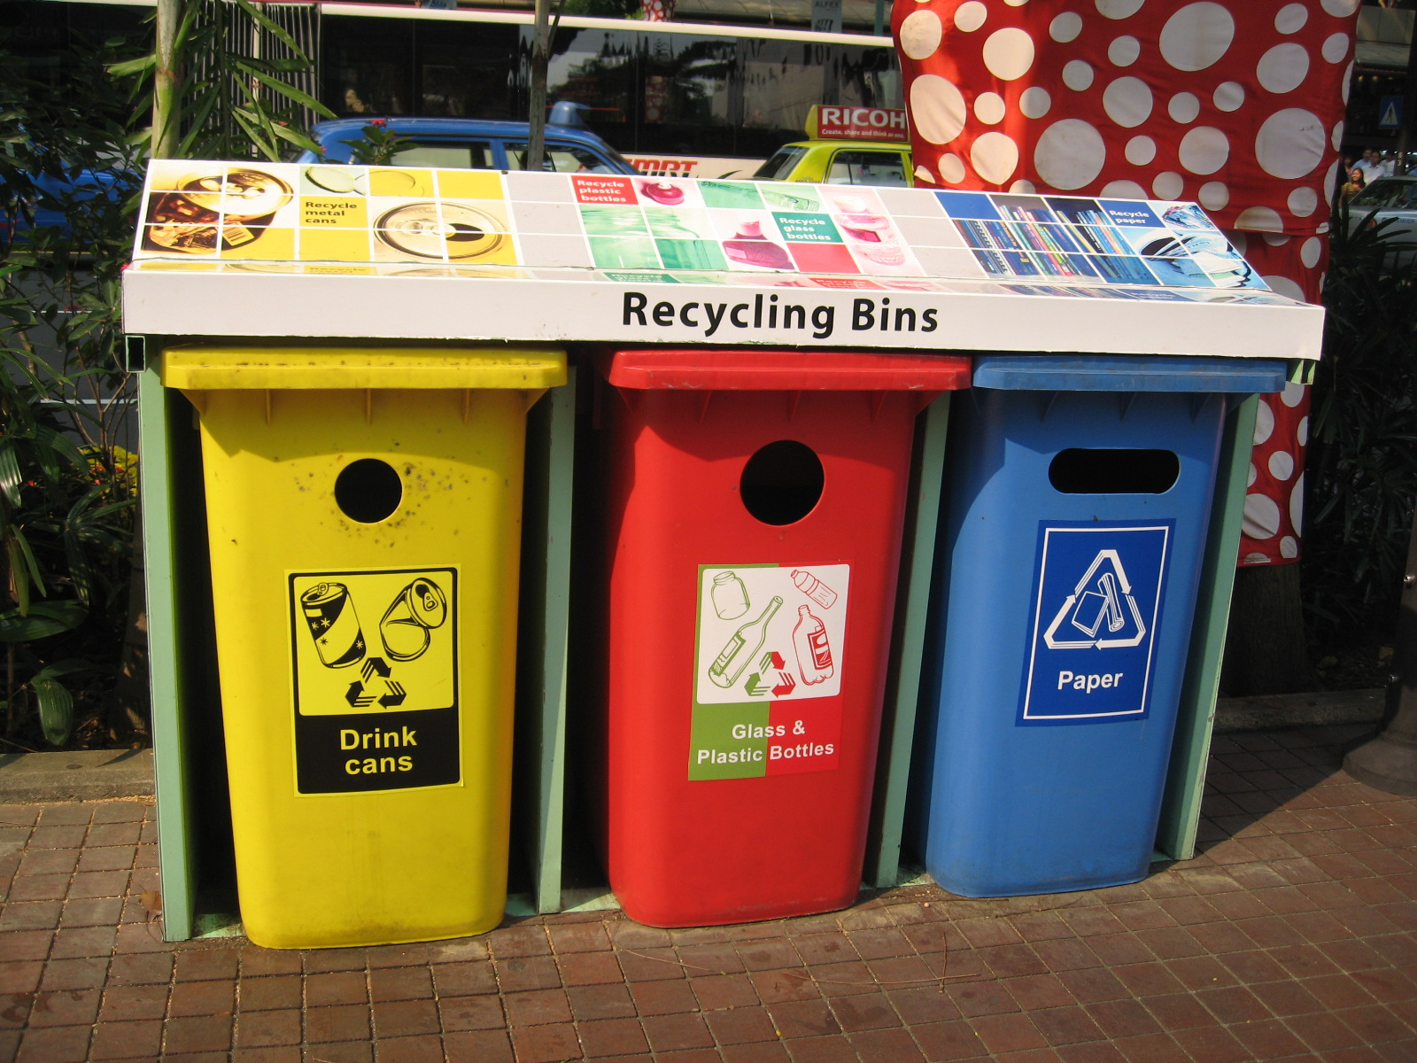
Photo from Wikimedia Commons, licensed under CC BY 2.5

6. Look for Certifications & Eco-labels
Labels such as “compostable,” “biodegradable,” “recyclable,” or those certified by credible third parties help identify products that fit within the circular model. Supporting these products helps build demand and eventually drives prices down.

Not sure about the difference between compostable and biodegradable? We’ve got you covered — check out our article where we explain it clearly. It’s a quick read that can help you make smarter, more sustainable choices. https://magno-project.eu/magno-consumers-insights-how-to-identify-biodegradable-or-compostable-packaging/

From Individual Action to Collective Impact
While individual actions may seem small in isolation, they become powerful when adopted collectively. As more people embrace circular choices, businesses and institutions are pushed to adapt.
We also know it’s easy to feel discouraged.
You might think: “What’s the point of me using paper straws when the ultra-rich are flying private jets?”
And honestly — you’re not wrong. We need more than just one person changing.
But here’s the thing: you control your actions, not others’. And when you act, you influence. If your decision inspires even one person, that’s already progress — and that person may inspire two more, and so on. This is how collective change begins.
All major social and environmental transformations started with small, individual actions that once seemed impossible to scale. Circular consumption is not just a trend — it’s a mindset. One that views waste as a design flaw, and participation as an opportunity.
We’re already seeing this shift: supermarkets are rolling out bulk refill stations, cafés are investing in returnable cup schemes, and startups are creating reusable containers, compostable trays, and smart packaging that monitors freshness. Many of these changes were sparked, at least in part, by evolving consumer expectations.

MAGNO’s Role: Empowering the Consumer
At MAGNO, we believe that systemic change begins with informed action. That’s why one of our pillars is improving consumer awareness and access to sustainable choices. Our mission is to make circular packaging not only available, but visible, understandable, and easy to engage with — so consumers aren’t just bystanders, but active contributors to a more sustainable future.

Final Thoughts
You don’t need to be perfect to make an impact. The circular economy isn’t about doing everything right, it’s about doing something better, consistently.
And yes, your small actions can change the world, dramatic as that may sound. For better or for worse, every choice counts. So don’t delegate your responsibility to others. Consumers hold far more power than we think, especially when we act together.
When our attention (and especially our money) is directed toward brands and products that respect the environment and promote circularity, the rest of the market has no choice but to adapt. The more we reward sustainable practices, the more companies will shift their design and production models to meet that demand.
By choosing reuse over single-use, looking for sustainable packaging, and holding brands accountable, we all play a role in reducing waste and closing the loop.
At the end of the day, the shift toward circular food packaging doesn’t just need policymakers or CEOs — it needs people like you.

