Plastic Promises: How Big Business Shapes Our Packaging Reality (And What Consumers Can Do About It)
In the supermarket aisles, it feels like we’re spoiled for choice. Eco-labels scream “compostable!” and “recyclable!” from every other product. But beneath this veneer of green lies a harder truth: consumers may shop with their values, but it’s the business world—especially the titans of industry—that writes the script.
In the context of the MAGNO Project, which aims to curb plastic pollution in food packaging, one thing is clear: the consumer voice matters, but the business model reigns supreme. And right now, too many of those models are built around plastic—cheap, versatile, of course safe, but devastatingly persistent plastic.

The Illusion of Consumer Control
We’re often told that our buying habits have the power to change the world. And yes, there’s some truth to that. Choosing fresh products, or sustainable packaging, supporting zero-waste brands, or demanding better labeling can nudge the market. But let’s not kid ourselves: consumers are playing on a field designed by big business.
Most packaging decisions aren’t made on ethics—they’re made on margins. Companies prioritize materials that are cost-effective and easy to mass-produce. That’s why, despite all the documentaries and data, the shelves are still wrapped in plastic. The system isn’t broken. It’s working exactly as intended—for profit, not the planet.
Major corporations hold an outsized influence on the packaging landscape. Their economies of scale mean they dictate trends, influence suppliers, and shape entire value chains. When they double down on single-use plastic or invest in non-recyclable materials disguised as innovation, they set a global precedent. It’s not just about your favorite soda brand using a plastic bottle—it’s that this practice ripples across continents, embedding linear wasteful models into economies far beyond Europe.
Even worse? Many of these companies engage in what experts call greenhushing—downplaying their environmental initiatives for fear of scrutiny—or greenwashing, where hollow sustainability claims mask business-as-usual operations. For every press release about biodegradable packaging, there’s a truckload of plastic entering landfills or oceans.

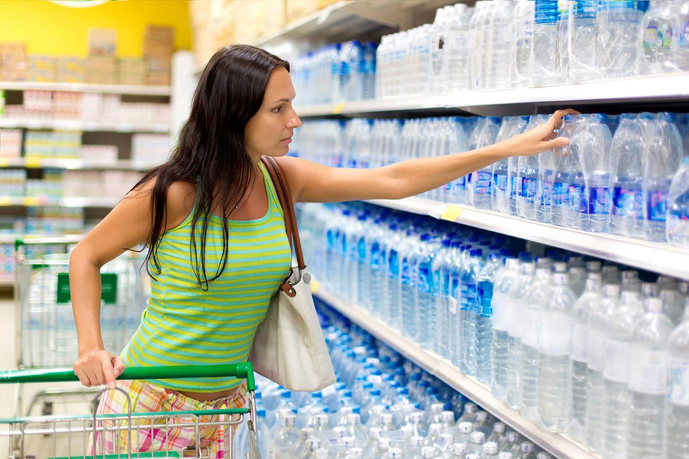
Photo by Tony Thiethoaly, licensed under CC BY-NC 4.0

Recycling: The Great Deflection. Business Models: The Real Battleground
Corporations love to point to recycling as the magic solution. “Just recycle it!” they say. But this neat narrative conveniently shifts responsibility away from producers and onto consumers. In reality, global plastic recycling rates hover around a dismal 9%. Much of what we toss into the blue bin ends up incinerated, exported, or simply landfilled—because it’s cheaper that way.
And even when recyclable materials are used, they’re often laminated, dyed, or contaminated in ways that render them impossible to process. Guess who designed that? Not you. Not your local zero-waste grocer. But the multinational that wanted a shinier package with a longer shelf life.
This is where MAGNO’s work is vital. It reframes packaging not as a technical problem, but as a business model issue. If the incentives remain the same—profit from volume, externalize waste costs, avoid regulation—then we’ll continue drowning in plastic, no matter how many bamboo forks we buy.
But if business models start rewarding reusability, refilling, and transparency—if companies are incentivized to innovate around function and sustainability rather than short-term gains—we might actually shift the paradigm. That requires pressure, both from policymakers and from us, the consumers.
Plastic isn’t a consumer choice—it’s a structural consequence of how companies are allowed to operate. If the business model rewards plastic, plastic is what we’ll get.
We need to flip the script. That means looking beyond packaging “innovations” and asking harder questions: Who profits? Who pays? And who really gets to decide what’s on our shelves?
Until companies are held accountable not just for the product, but for the packaging that wraps it, as we are responsible if we litter the streets, no amount of consumer virtue will solve the problem. It’s time we stop being passive buyers and start acting like the stakeholders we are.

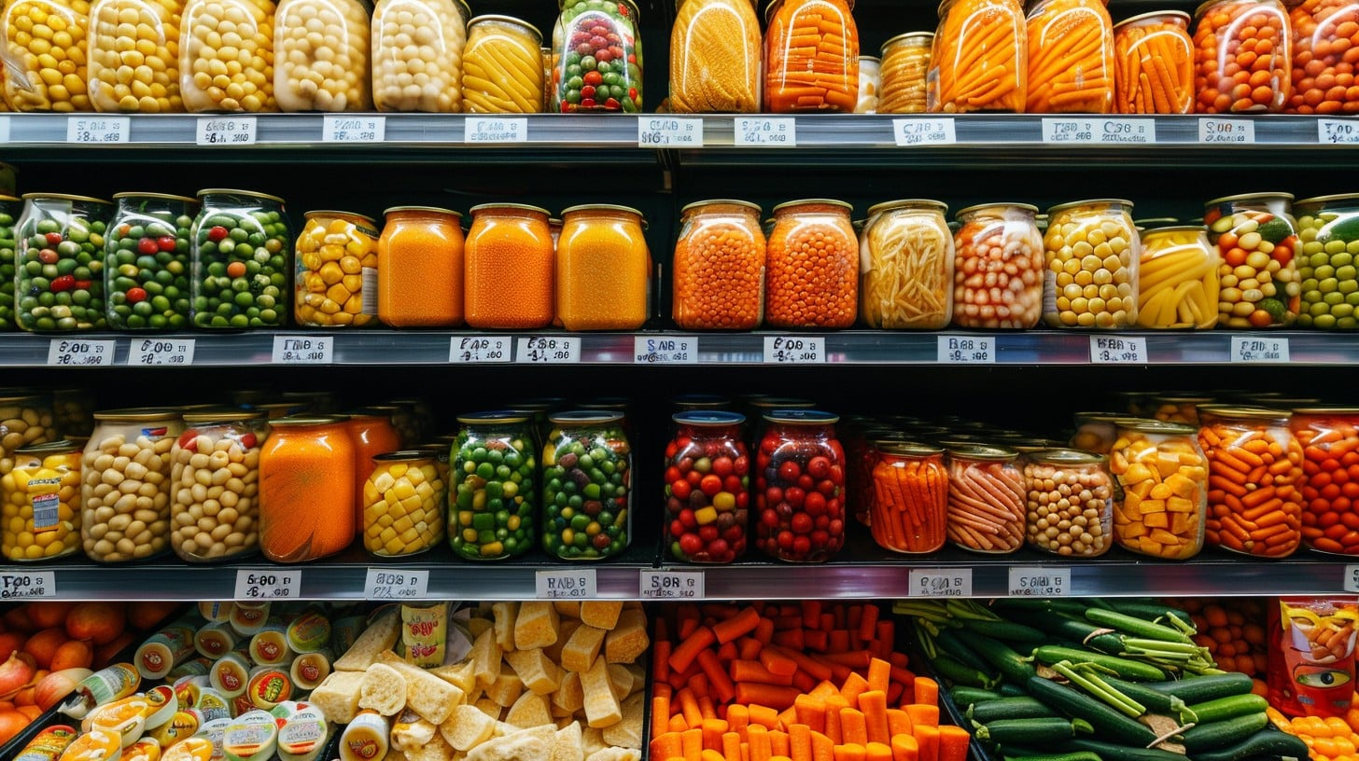
Photo by StockCake, licensed under CC0 1.0

So, What Can We Do?
We may not own factories or dictate supply chains, but we’re not powerless. Here’s where our influence lies:
- Demand transparency: Call out companies hiding behind vague green claims. Ask for proof—LCAs, clear recyclability data, third-party certifications.
- Buy less, buy smarter, buy fresh: Choose brands that prioritize reusable or returnable packaging, even if it costs a bit more.
- Support regulation: Advocate for policies that force companies to internalize their environmental costs. The Single-Use Plastics Directive didn’t happen by accident—it was public pressure that moved the needle.
- Disrupt the narrative: Talk about the real power dynamics behind plastic. Educate friends and family. Stop accepting the idea that it’s all on us.
For a deep dive into how business models can drive sustainability in food packaging, don’t miss this essential read from the MAGNO Project research team:
Food packaging business models as drivers for sustainability in the food packaging industry

