Choosing Reusable over Single-Use: Why It Really Pays Off
We live in a world drowning in disposables. Coffee comes in cups designed to last minutes, groceries in bags that survive centuries, and takeaway in boxes we forget about before the meal is even finished.
The promise of convenience has left us buried in waste.
That’s why “reusable” became such a powerful word. It promised simplicity, responsibility, even a touch of pride. Carrying a tote or a steel bottle became a quiet way of saying: I care.
But let’s be honest. How many of those “reusables” are actually used enough to matter? How many end up stuffed in drawers, left in the car, or abandoned after a few weeks? We don’t always like to admit it, but sometimes the problem isn’t that reusables don’t work—it’s that we don’t.
You’ve heard it a thousand times: “Say no to single-use, choose reusable!” But then someone pops up with a scary number: “Did you know a cotton tote needs 7,000 uses to beat a plastic bag?” Suddenly, it feels like reusables are a scam.
The truth? Reusables work—but like gym memberships, they only pay off if you actually use them. Here’s what the evidence says, in plain English.

Bags: The Tote Myth
Yes, the famous cotton tote comes with a big footprint at the start. If you only use it a handful of times, you’re right: the thin plastic bag wins. But keep reusing it—week after week, for years—and the story flips. A UK study calculated that for climate impact alone, a cotton bag pays off after about 131 uses (UK Environment Agency, 2011). That’s like using it for your weekly shop for just over 2 years.
And let’s be honest: most of us already use our bags far more than that without even thinking about it. From groceries to gym clothes to carrying lunch, a single tote can quickly rack up those numbers.
The real villain? Collecting dozens of totes you never use. One reusable bag, used often, beats an army of “eco” bags stuffed in a drawer.
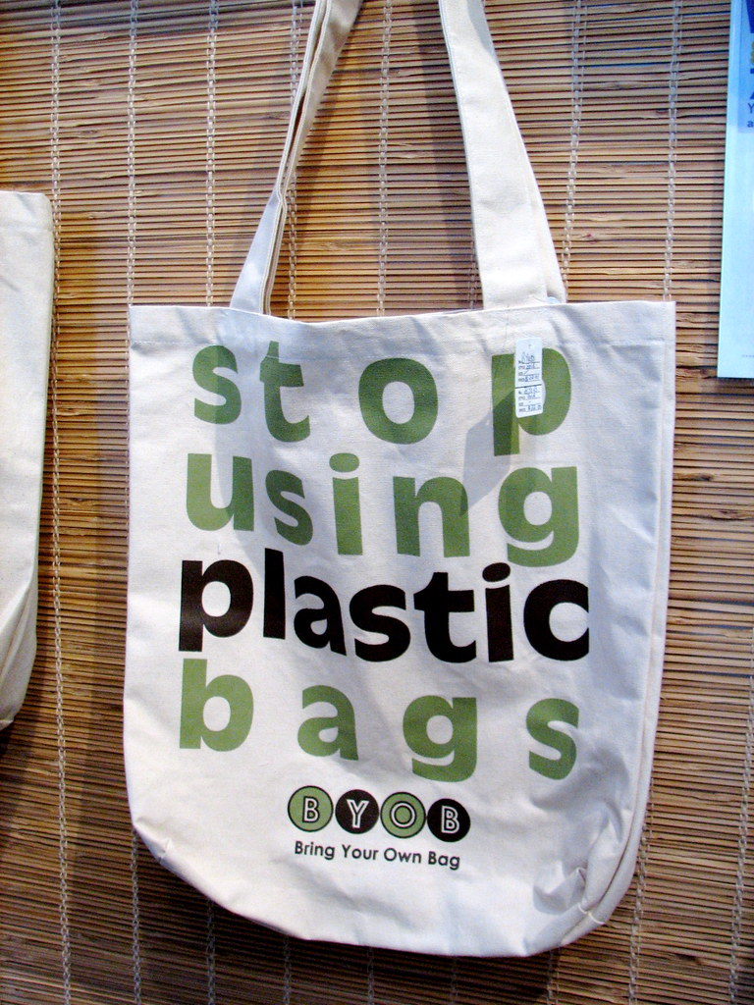
Photo by Dave O (Flickr), licensed under CC BY-SA 2.0

Coffee Cups and Takeaway Boxes
Here’s where reusables shine fast. A study for Zero Waste Europe found that a reusable plastic coffee cup beats disposables after just 6 uses. That’s one week of morning lattes. For takeaway food containers, it’s around 13 uses (Zero Waste Europe, 2023).
Think of it like this: if you grab lunch at work twice a week, your reusable container already outperforms disposables in little more than a month. After that, every single meal packed in it is a clear win for the planet. And the truth is, most of us stick to the same cup or container once we find one we like— so hitting those numbers happens quicker than you’d expect. Even better, you save yourself from the sad experience of flimsy lids and soggy cardboard.

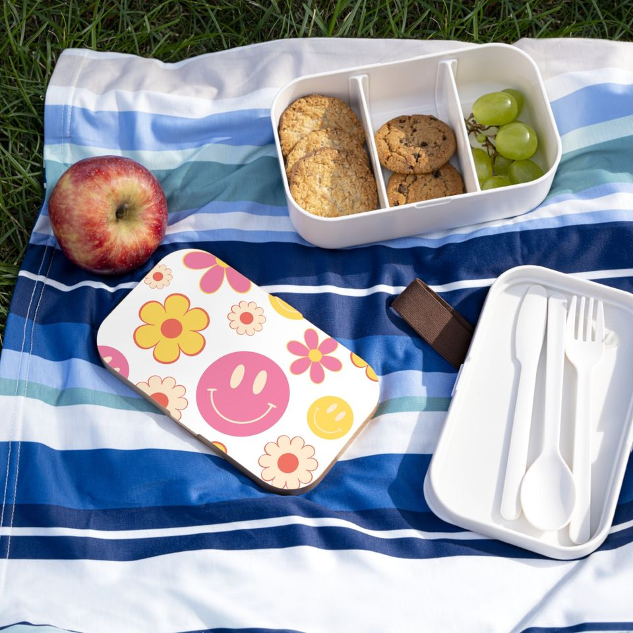
Photo by Pinterval, licensed under CC BY-NC 4.0

Water Bottles: The Easiest Win
Here’s the simplest swap of all: bottled water versus tap water in a reusable bottle. According to the ISGlobal, bottled water can have up to 3,500 times the climate impact of tap water (The Guardian, 2021). A sturdy stainless-steel bottle might need dozens of refills to pay back the production footprint—but if you’re drinking water daily, you’ll get there in no time.
Oh, and bonus: you save money. A reusable bottle can save you hundreds of euros a year if you stop buying plastic bottles at €1-2 a pop. That’s not just a climate win, but a personal finance hack.

Deposit-Return Bottles
Where deposit-return systems exist (like in Germany or soon across much of the EU), reusables are a no-brainer. Up to 90% of bottles are returned and reused (Reloop, 2024).
It’s the simplest environmental hack: you get rewarded for doing the right thing, the bottle gets washed and reused, and nothing ends up in the trash. Once you try it, you can’t help but wonder why it isn’t the default everywhere.

Curiosities You Might Not Expect
- Reusable cutlery sets: Forks made from reusable plastic or metal, outperform disposables after fewer than 12 uses (University of Michigan, 2021). In other words: whether you pack sturdy plastic, or that camping fork, just a dozen meals is enough to tip the balance.
- Cloth napkins: According to some LCAs, if you wash them efficiently, they beat paper napkins after just a few dinners. Also: they make your table look classy.
- Reusable straws: Stainless steel straws only need 37–63 uses to pay off their impact. So if you’ve got one, keep it in your bag and use it whenever you need it. (Chitaka et al., 2020).

A Final Reflection
So, what is the conclusion? Reusables aren’t a scam, they’re simple math.
That tote bag that’s been with you on countless grocery runs, or that bottle that follows you from the office to the gym and back again. Each one begins as a small habit, almost invisible on its own. But reuse after reuse, the impact snowballs. Unlike single-use items, which start and end in an instant, reusables gain value with every round. The longer you keep them in play, the bigger the win—for you, and for the planet.
But here’s the irony: reusables are supposed to be the accessible, common-sense solution. Yet little by little, they’re being turned into lifestyle accessories for the privileged few. Walk through a trendy neighborhood and you’ll see the paradox in action: a cotton tote bought during a weekend in Paris, dangling from one arm; a €10 specialty latte in the other, served in a disposable cup lined with plastic; and inside the tote bag, a shiny €50 Stanley Cup that’s more a useless status symbol than a climate solution. This is where sustainability gets messy. Because when reusable culture turns into consumer culture, we’re not breaking the system, we’re just repainting it green.
That is the opposite of what we need. Being part of the solution cannot depend on how much you can afford to spend on “eco” products.
A system where green choices are luxury choices will never fix the waste crisis—it will only deepen inequalities.
The truth is you don’t need an army of trendy gadgets to live sustainably. You only need one tote bag—and you use it until it falls apart. You don’t need a €50 stainless steel bottle —your old gym bottle, the one you’ve carried to football practice or camping trips for years, works perfectly. You don’t need bamboo cutlery that comes in a pouch with a hipster logo—your normal fork from the kitchen drawer does the job just fine. Reusables are powerful because they last, not because they look good on Instagram.
It’s important not to confuse sustainability with fashion, because if we let that happen, the solution simply gets muddled by the same consumption patterns that created the waste crisis in the first place—turning solutions into yet another business opportunity.
Real change is built on simplicity, durability, and access for everyone.

