Buying in bulk to minimize packaging: Encouraging eco-friendly shopping behaviors
Written by: Phil Rosenow

Between small sachets with single servings of sugar or cream and large containers with ingredients for cafeterias, food packaging comes in all different sizes. Even at the supermarket, we choose between single portions and family packs. This variety suits different lifestyles, of course, but how can buying in bulk be more eco-friendly? And what do we need to look out for?

Why buy in bulk?
Here’s the simple math: the bigger the package, the less packaging material is needed per unit of food.
Now, stay with me. Let us imagine a piece of packaging shaped like a cube. The surface of the cube corresponds to the amount of packaging material we need, the volume to the amount of product we can package.
The surface grows with the square of the length of the edge, the volume with the cube of the length (square-cube law). In other words, if we double the length of the edges, we increase the surface four times and the volume eight times. Thus, we need four times as much packaging material (perhaps a little more if we need to make it thicker) to package eight times as much product. So, a bigger packaging unit can hold more food than a smaller one, while using relatively less material. Or: we can get more food for less packaging.


 | Small cube | 8 small cubes | Large cube
Edge | 1 cm |  | 2 cm
Volume | 1 cm³ | 8 cm³ | 8 cm³
Surface | 6 cm² | 48 cm² | 24 cm²

To illustrate this, let us imagine packaging in the form of a small cube with an edge of 1 cm and one larger cube with twice the edge. To match the volume – or amount of product – of the larger cube, we would need eight small ones, amounting for twice the surface – or amount of packaging – compared to the larger packaging, as shown in the image below.
While most packaging in the wild does not come in the shape of a cube, the principle holds up for other types of packaging as well: by comparison, the 10 kg bag of rice uses less material than ten 1 kg bags. And since rice lasts quite a long while, the larger bag may be well worth it for a household where rice is eaten a lot.
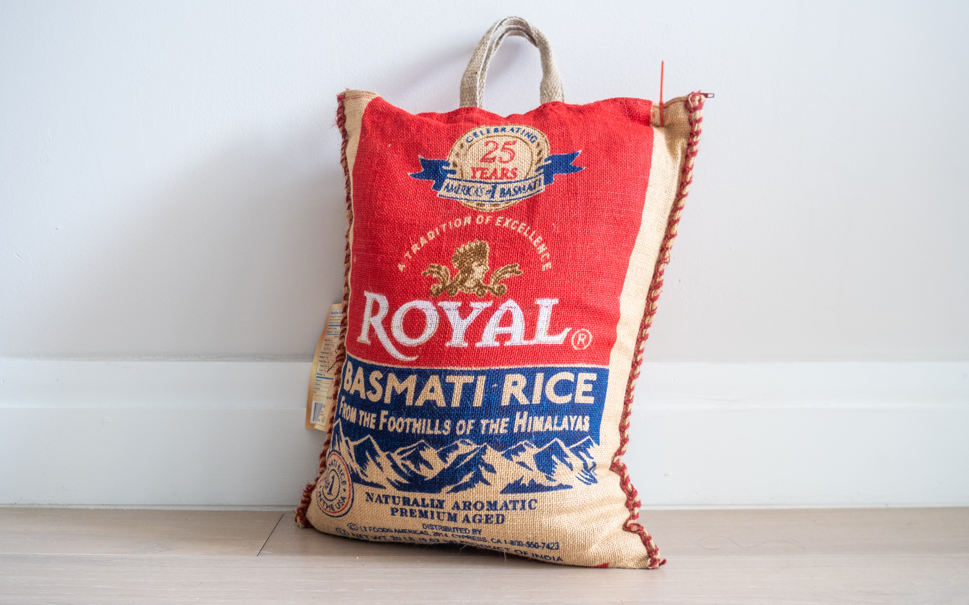
Photo by Ajay Suresh (Wikimedia Commons), licensed under CC BY 2.0

Why not buy in bulk?
But let’s not get carried away. Are there cases where we might not want to buy in bulk? For almost all foods, with mineral water being the notable exception, producing the food has a larger environmental impact than producing the packaging. With that in mind, if a larger package means part of the food will spoil after opening, the smaller option is often the better choice (unless the leftovers can be frozen or otherwise made to last). This applies mainly to perishable foods that will be kept for a long time after opening the package. If the packaging is not resealable, the larger packaging may be more at a disadvantage.
In other words, wasting food is worse than using extra packaging.

What to buy in bulk – and what not?
In short, buying in bulk means using less packaging material and putting more food into one package. For long-lasting staples, bulk packaging is a better choice compared to smaller units, as far as eco-friendliness is concerned. For any perishable goods that are used up in one go – or perhaps in a few days – bulk packaging produces less waste compared to buying the same amount of food in several smaller packages. Depending on the producer and the market, buying in bulk might also be cheaper! So, when is buying in bulk the eco-friendly choice?
Shelf-stable staples: rice, flour, sugar, dried pulses and legumes, dried pasta
- Resealable containers with preserved foods: pickled foods, marmalade/jams, condiments – always provided, no dirty cutlery enters the container
- Generally, foods that last a while after opening
- Anything that is used quickly after opening (where “quickly“ depends on the food): ingredients for large meals, meal prepping etc.
On the other hand, if the food needs to be kept for longer after opening and is a bit more perishable, the smaller size might be the eco-friendlier choice as no food is wasted. Here, it is beneficial to buy the size according to one’s needs. Examples include:
- Fresh, unpreserved meat and fish – these often only last a short time, so keeping them open for more than a day or two is unadvisable
- Anything packaged under a modified atmosphere. This is usually done to extend the shelf life of the product. Once the package is open, the modified atmosphere is gone, and so is its protective function. Depending on the product, spoilage may occur within a few days. Modified atmosphere packaging is usually declared on the package.
Then of course, there are some cases where we can make an argument for both. Chips for example: once a bag is open, it will be emptied quickly, no matter the size. They will, of course, go right to our hips.

What clues do we get from the packaging?
Looking at the packaging can give us some insights on whether or not buying in bulk is worth it. If the packaging gives us some information about how long we should take to use the product after opening, we get a very useful piece of information. If the package tells us to use the content “within a few days”, we should probably only buy as much as we need within that time (or turn the rest into something more lasting).
Another way is to look at the packaging material itself: if it is really simple, especially if it is just paper or cardboard, the product itself is probably quite stable (e.g. flour, sugar, pasta) and will keep a while – buying in bulk is definitely an option. If the packaging is more complex, especially if there is visible metal on a plastic packaging, the product is probably quite susceptible to spoilage and is protected by the packaging. This indicates that the product will not last long after opening – buying just what we need in the short run might be the better option here. As mentioned above, references to modified atmosphere packaging (MAP) also indicate a delicate product.
YES:
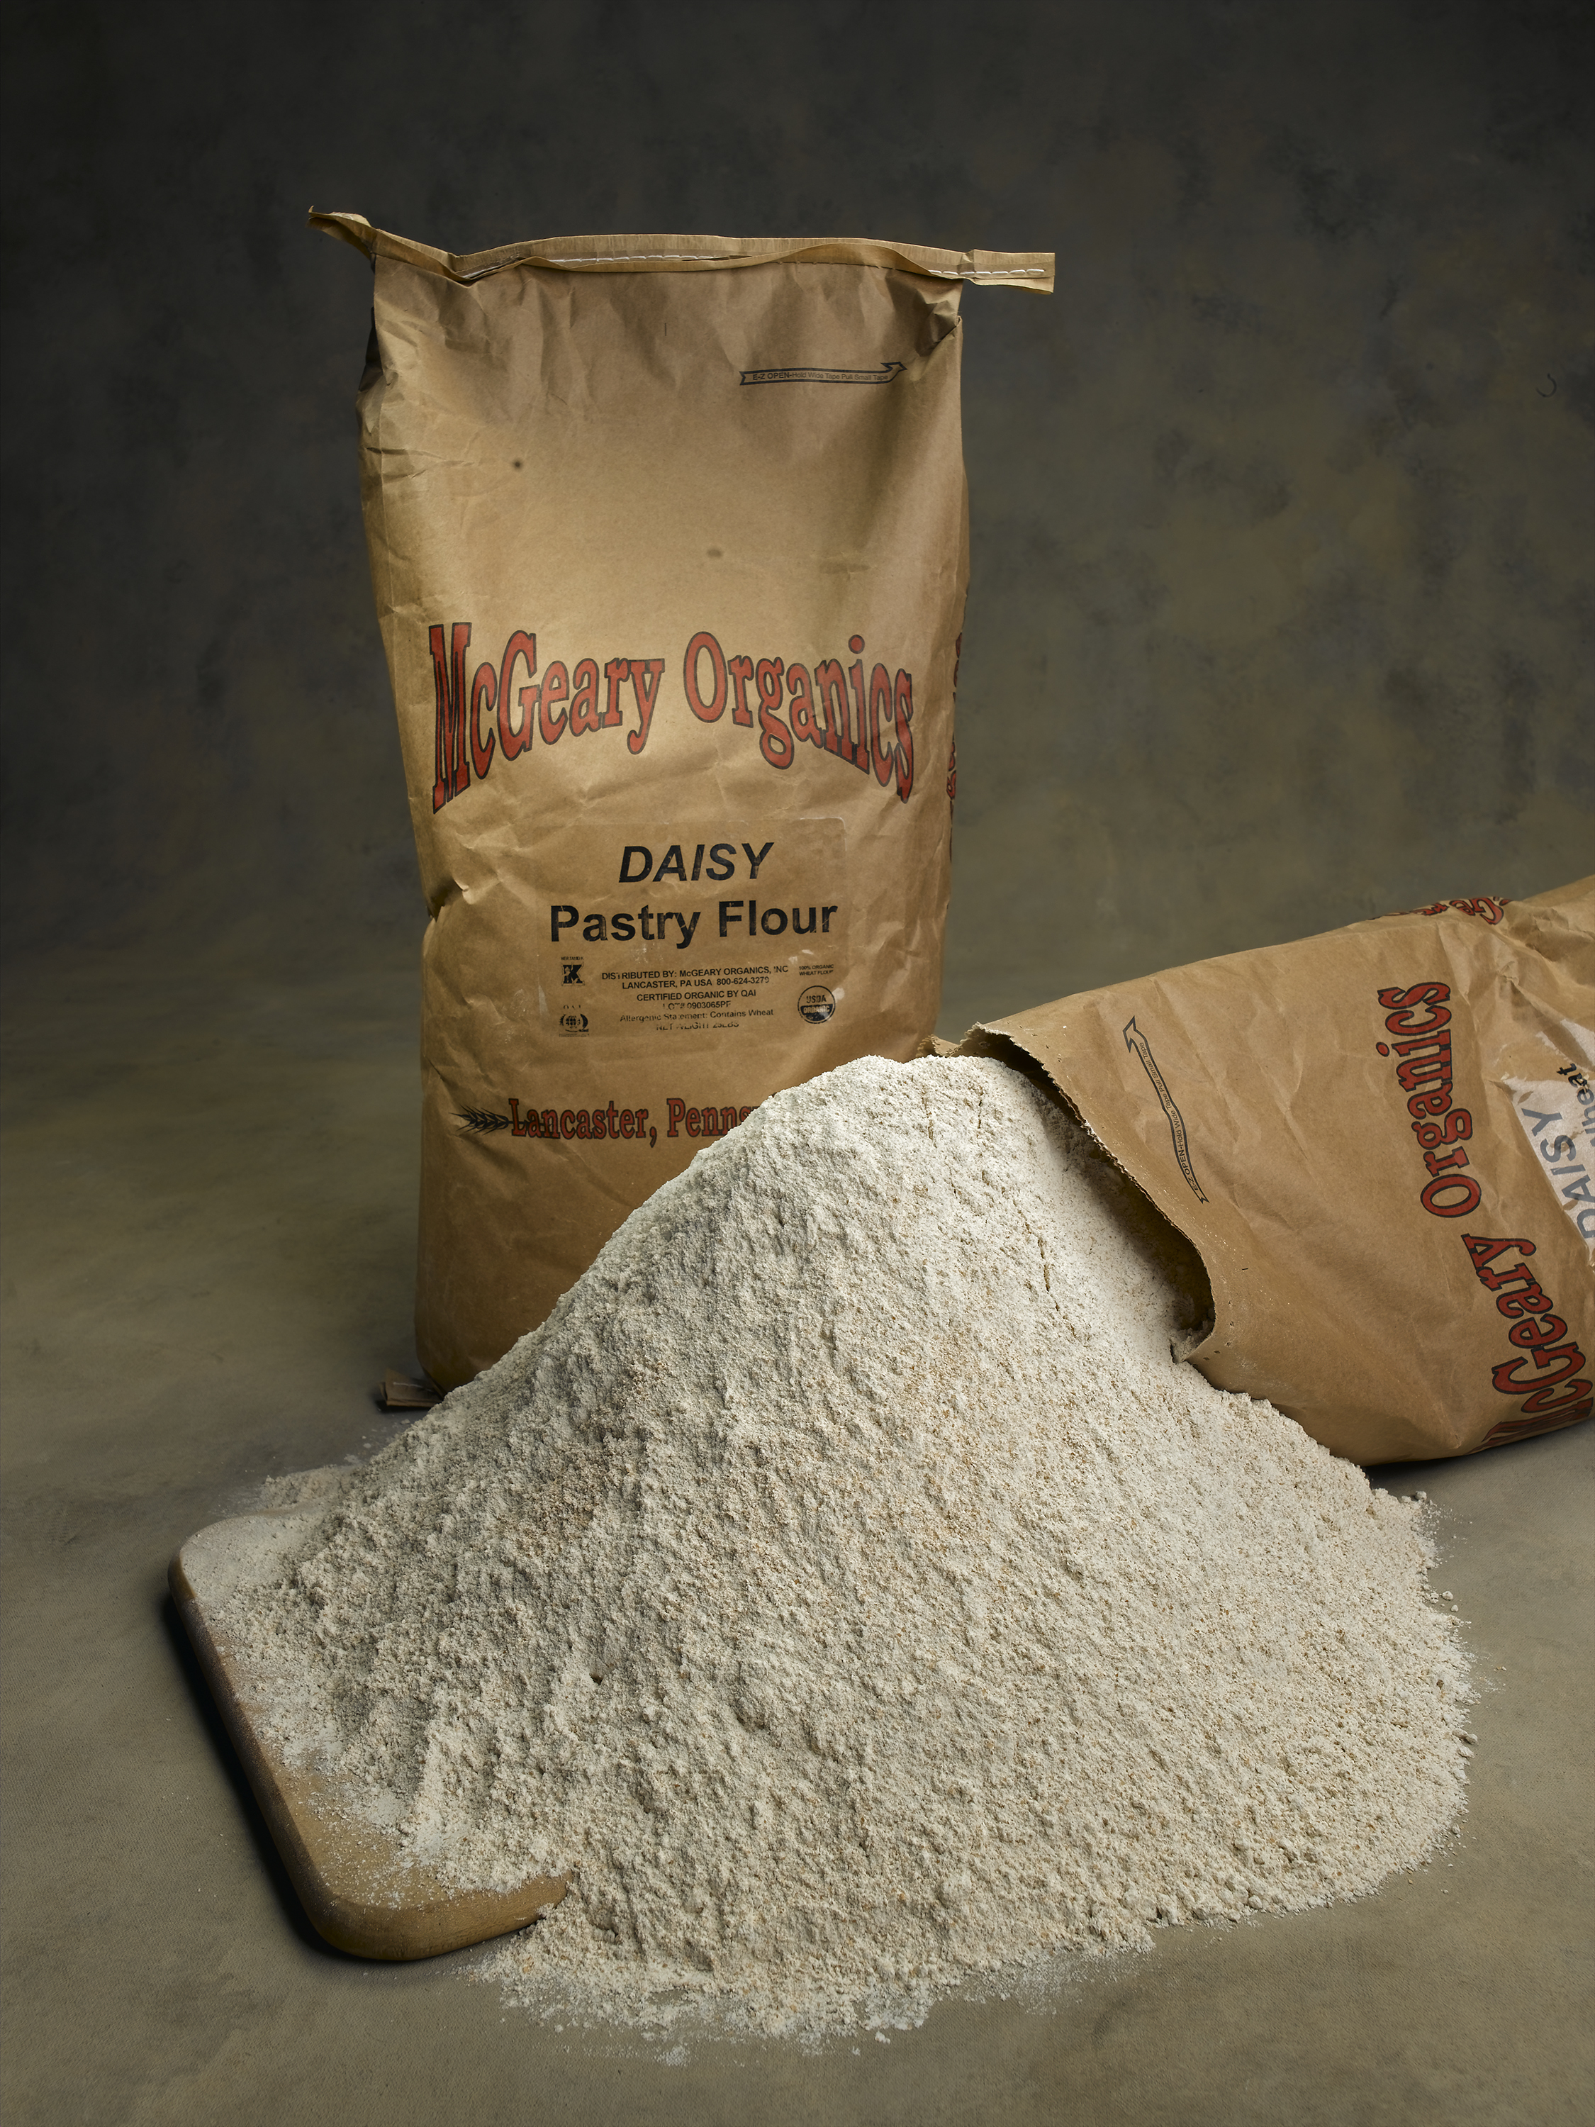
Photo from Wikimedia Commons, licensed under CC BY-SA 3.0

What is the conclusion?
Buying in bulk doesn’t mean turning your kitchen into a survivalist bunker. It’s not about stacking towers of rice bags or pasta packs until your cupboards groan. It’s about balance. When the food lasts—like flour, beans, or rice—bigger packs mean less packaging and less waste. When the food spoils quickly, smaller packs are the smarter, greener choice.
Sustainability it’s about matching what you buy with what you actually eat. A 10-kg bag of rice that feeds your family for months? Great choice. A family-sized tray of fresh fish that ends up in the bin? Not so much.
The golden rule? Bulk is better when it saves packaging without creating food waste. Buy with your habits in mind, not just the “eco” label on the shelf. That’s where the real impact lies.

