Recycling Is Broken: Common Mistakes We Keep Making (and How to Fix Them)
We like to believe recycling is simple: toss your plastic bottle or cardboard box into the right bin and you’ve done your part for the planet. Companies will do their part. But the reality is far messier. Recycling is often treated as the ultimate solution, when in fact it is fragile, complicated, and easily undermined by our mistakes and bigger stakeholders (mostly). A dirty yogurt pot or a greasy pizza box can ruin entire batches of recyclables, sending them straight to landfill but then why recycle. It is true the model need to be reviewed. Meanwhile, companies keep flooding the market with “innovative” packaging that is impossible to recycle. If we are serious about tackling waste, we must first get brutally honest about what we, as consumers, are doing wrong—and how to do better. And then, ask to others.

When you try your best, but you don’t succeed: The Mistakes That Kill Recycling
The first mistake? Throwing dirty packaging into the recycle bin. No matter how recyclable a container is in theory, once it’s covered in food residue, it contaminates everything around it. That “eco-friendly” gesture of tossing your sauce-stained plastic tray into the recycling bin? It may have just condemned an entire load to the incinerator.
Then there’s the blind faith in plastics. We’ve been taught to believe that every piece of plastic is recyclable, but most aren’t. Films, pouches, multilayer wrappers—these are design failures disguised as convenience. Recycling plants cannot process them, yet they continue to pile up in bins and clog the system.
Paper isn’t immune either. Pizza boxes soaked with grease or coffee cups lined with plastic are recycling illusions. They look harmless, but they can’t be processed and only make things worse. It is true that Pizza Boxes by nature will be greasy but then, why recycling. Better regular garbage and then request for a more sustainable model. Maybe we need to eat less delivery pizza. And compostable packaging? The confusion is even greater. Instead of being placed in the biowaste bin, it often ends up contaminating plastics recycling, proving once again that good intentions without knowledge do more harm than good.
Lastly, we are often too lazy—or too rushed—to separate materials. Cardboard sleeves stuck to plastic trays, foil lids attached to yogurt pots, glass jars thrown in with their caps. Each time we skip that extra step, we make it harder for recycling systems to work, and easier for waste to be dumped.

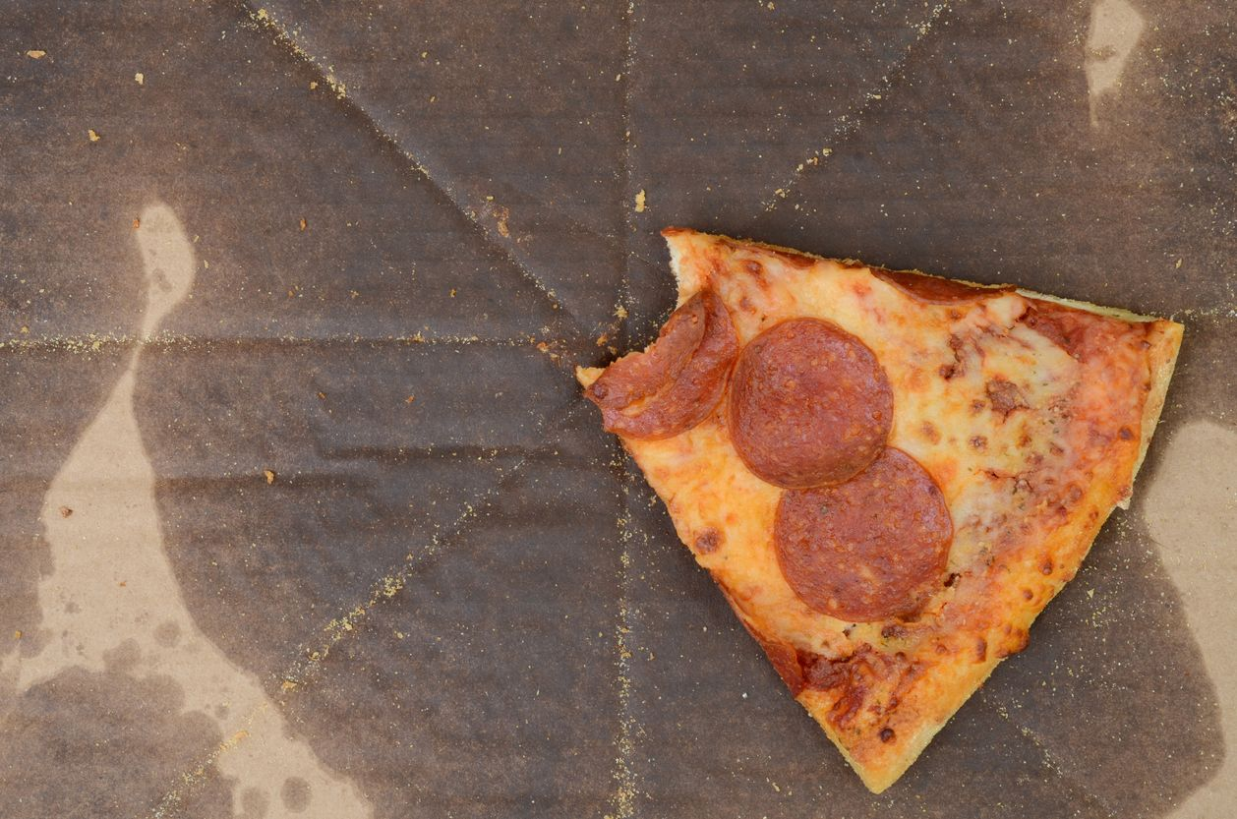
Photo from Heute.at, licensed under CC BY 4.0

Why one wrong item can ruin recycling: The Domino Effect of Contamination
Contamination in recycling doesn’t stop at a single item — it spreads through the system like falling dominoes. What starts as one misplaced or dirty piece of packaging can compromise entire collections.
When contaminated materials arrive at sorting facilities, several issues unfold:
- Clean recyclables become unusable. Food residues soak into paper and cardboard, while shards of broken glass or leftover liquids make other materials unsafe to process.
- Machinery is damaged or blocked. Flexible plastics, textiles, or other inappropriate items can jam conveyor belts, wrap around mechanical parts, or even trigger fires.
- Sorting slows down and costs rise. Once contamination appears, manual intervention is required. Workers must remove dirty or incorrect items by hand — a slow, costly process that reduces the overall recycling rate.
- Entire loads are reclassified. When the contamination level is too high, recyclables lose their value and are redirected to general waste or incineration, undoing all prior separation efforts.
The impact is both environmental and economic. Contaminated recycling increases processing costs, wastes recoverable resources, and undermines circular economy targets. Every load that ends up in landfill or incineration means more emissions, more lost materials, and less progress toward a sustainable system. («The Hidden Cost Of Contamination: One Wrong Item Can Ruin Recycling», 2024)

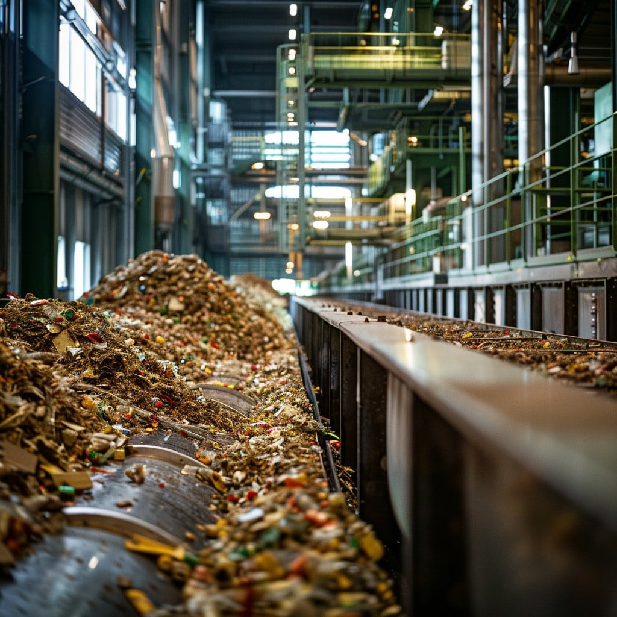
Photo from StockCake, licensed under CC0 1.0

I promise you I will learn from my mistakes: The Best Practices We Cannot Ignore
The antidote to these mistakes isn’t rocket science—it’s minimize consumption and maximize care. Purchase less, purchase better and in then rinse your containers. Flatten your boxes. Separate your materials. These aren’t heroic actions; they’re the bare minimum if we want humans to continue living in a liveable planet. Of course, others also need to take their responsibility, and im looking to Governments, Leaders and Companies.
We also need to get real about compostables. If your city doesn’t have an industrial composting system, your “compostable” coffee cup is just another piece of trash. Tossing it into the recycling bin doesn’t make you eco-conscious—it just sabotages the process. Please, think twice and do not get mislead by marketing tricks.
And when in doubt, once again, throw it out. Yes, that sounds counterintuitive, but a single wrong item in the recycling stream can contaminate far more than one piece of waste in general rubbish ever would. It’s better to sacrifice one wrapper than ruin a ton of recyclables.

When you’re too in love to let it go: The Bigger Picture
Here’s the uncomfortable truth: even if every consumer followed these rules perfectly, recycling -if even perfect- alone would still not save us. The system is rigged in favor of companies that design disposable, non-recyclable packaging because still cheap and profitable. Then, average companies go greenwashing and little really look at the bigger picture and produce responsible packaging, if that even exists in terms of waste management. Shifting all the responsibility onto households is convenient for them, but misleading for us. Consumers can do their part—but unless corporations redesign packaging with recycling in mind, we are just cleaning up a mess someone else keeps making.

And I will try to fix you…
Recycling is not a magic cure. It is fragile, messy, and constantly sabotaged—by careless habits, by misleading “eco” strategies, and by industries more interested in profit than sustainability by nature. If we want recycling to work, consumers must step up, yes—but companies must stop treating pollution as a side effect of business but a core cost. Until then, the least we can do is stop making the mistakes that keep the system broken. Rinse, separate, question—and refuse to play along with the illusion that recycling is enough.
If you want to go a step further and learn what actions are truly more effective than recycling, take a look at our article on the 5Rs — Refuse, Reduce, Redesign, Reuse, and Recycle — where we explore how consumers can make real impact beyond the bin.

