It is not rocket science. We used to have it: Supporting Reusable Packaging

Single-use packaging is one of the most visible symptoms of our throwaway culture. From coffee cups to takeaway containers, the sheer volume of waste created daily is staggering (and unsustainable).
I just tried this morning to avoid buying plastics in general and for single use in particular, and in real conditions it is really hard, if not impossible. Businesses do not favour these options, nor do the government regulate them enough to protect us from irresponsible business models. Recycling alone cannot solve the problem. What we need is a shift toward reusable packaging systems that cut waste at the source and embed circularity into everyday life. It is not difficult; we had in the past all through the 20th century with less technology. Cristal milk glasses, textile bread bags for daily made local bread. You name it.
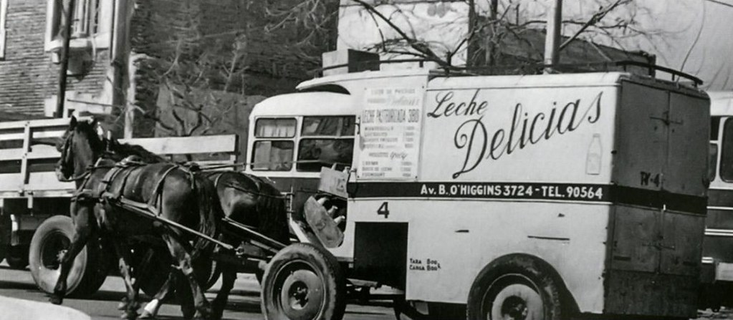
First photo from Flickr, licensed under CC BY-ND 2.0 – Second photo from Public Domain Pictures under CC0 1.0

Why Reusable Packaging Matters
Reusable packaging, if not reduces consumption, reduces waste, lowers emissions, and conserves resources. Unlike recycling, which often downcycles materials into lower-value products, reuse maintains materials in circulation at their highest value for longer. It’s not just an environmental win, but also creates economic opportunities for businesses that adopt innovative service models, like deposit-return systems, refill stations, or subscription-based reusable container services.
But adoption has been slow. Why? Because throwaway packaging is cheap, convenient, and backed by entrenched supply chains. Businesses fear losing benefits by added costs, and consumers often don’t see viable alternatives. Overcoming this inertia requires both community-level engagement and corporate accountability.

How Communities Can Encourage Reuse
Communities play a crucial role in normalizing reuse:
- Local governments can implement deposit-return schemes or require businesses to offer reusable options.
- Schools and universities can introduce reusable container systems in cafeterias to set behavioural norms early.
- Citizen initiatives—from zero-waste shops to neighbourhood swap networks—create visible, grassroots alternatives.
When reuse becomes easy, affordable, and socially accepted, adoption skyrockets.

How Businesses Can Lead
Businesses can no longer hide behind the “consumer choice” excuse. They have the resources and influence to redesign packaging models that prioritize reuse. Some actions include:
- Partnering with logistics providers for reverse collection of reusable containers.
- Offering discounts or loyalty points for customers who opt into reuse programs.
- Redesigning packaging for durability, stackability, and easy cleaning.
Forward-thinking companies are discovering that reuse is not a burden, it’s a way to build stronger brand loyalty and cut long-term costs. Once again, is not rocket science, it is just responsible business.
If companies do not want to be accountable for their abuses or law misinterpretation, policy makers, as elected politicians representing citizens interests, must step in to create a level playing field. Subsidies and tax breaks for reusable systems, bans on unnecessary single-use items, and extended producer responsibility (EPR) laws can accelerate the transition. Without regulatory frameworks, voluntary adoption will remain too slow to meet climate and waste-reduction goals.

Why the MAGNO Project Matters
This is where initiatives like the MAGNO project come in. MAGNO is important because it brings together businesses, communities, and policymakers to pilot scalable reusable packaging systems. Instead of treating reuse as a niche experiment, MAGNO tests real-world solutions that can be replicated across regions and industries. By combining technical innovation (tracking, cleaning, logistics) with social innovation (consumer incentives, awareness campaigns), the project addresses the practical barriers that have long slowed down reuse adoption.
Most importantly, MAGNO proves that collaboration—not isolated efforts—is the key. It shows how shared infrastructure and cross-sector partnerships can make reuse economically viable and socially attractive, setting a blueprint for others to follow.

In sum…
Reusable packaging is not a utopian idea, it’s a practical, necessary step toward a sustainable future. Communities can normalize it, businesses can scale it, and projects like MAGNO demonstrate how to make it work in practice. The challenge is not technological, it’s cultural and structural. By supporting reuse, we are not just reducing waste; we are reshaping the relationship between consumers, companies, and the planet. There is no planet nor population B.

