The pros and cons of biodegradable plastics: Educating consumers on their limitations and benefits
Biodegradable plastics have been marketed as the “miracle solution” to plastic pollution. Packaging that dissolves, cups that claim to vanish into the soil, bags labeled as “eco”—what could be better? On the surface, it feels like we’ve finally found a way to reconcile convenience with sustainability. But scratch a little deeper, and the story is more complicated—and far less flattering for companies pushing it, because there is no standard definition.

The Mirage of the “Green Label”
Let’s start with the truth: most biodegradable plastics don’t simply disappear. They require specific industrial conditions to break down—high heat, controlled humidity, oxygen levels— that rarely exist in the real world. Toss them in your backyard compost, a landfill, or the ocean, and they will linger for years. Worse, many fragment into microplastics, polluting the environment under the guise of being “eco-friendly.” Whatever that means.
It is a well-known situation, but many hide behind marketing strategies, whilst profiting from consumers’ guilt and desire to do the right thing. Instead of redesigning packaging systems or scaling reusables, they slap “biodegradable” on a single-use item and move on. It’s a textbook example of greenwashing.
To be fair, not everything is bad. Biodegradable plastics do have benefits—if managed correctly. In regions with proper industrial composting facilities, they can reduce waste volumes and provide an alternative to petroleum-based plastics. They can be useful in specific applications where contamination makes recycling difficult (like food-soiled packaging). And yes, they can reduce dependence on fossil fuels if produced from renewable resources.
But those benefits depend on infrastructure, policy, and consumer education. Without clear systems to collect and process them, biodegradable plastics can be just as wasteful as the “old” plastics they claim to replace.
Here’s the uncomfortable part: the problem isn’t the material itself; it’s the economic system wrapped around it. Companies keep producing more single-use items, just swapping “petroleum” for “bioplastic.” Governments, meanwhile, play referees with half-baked rules, torn between protecting corporate privileges, revolving doors, and serving the public interest.

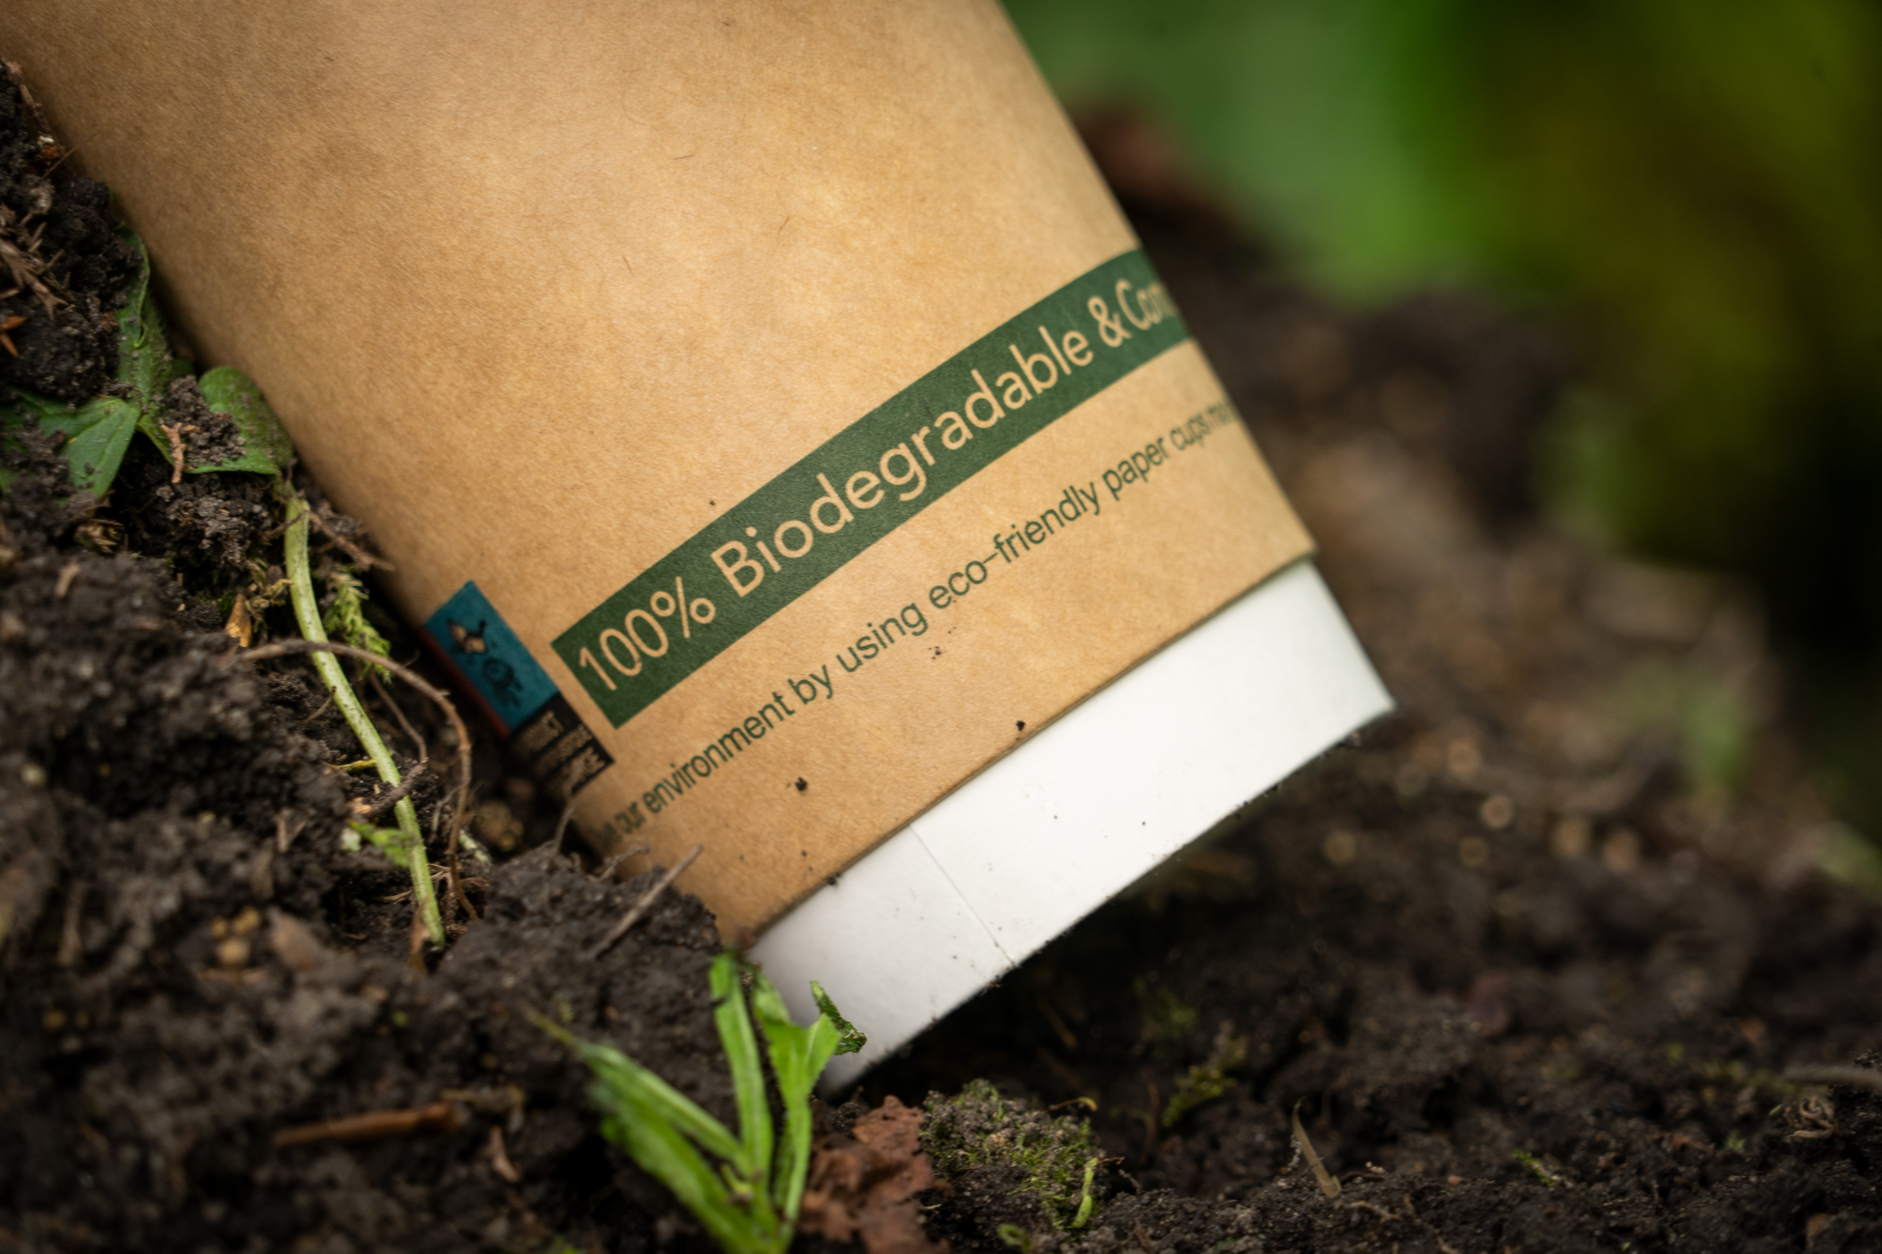
Photo from Wikimedia Commons, licensed under CC BY 2.0

The Real Problem: Business Models and Policy Gaps
Consumers must see through the “biodegradable” mirage. It’s not enough to trust labels; we need to demand real systemic change:
- Push for policies that favor reuse and redesign, not just material substitution.
- Support community-level waste solutions and local composting initiatives.
- Hold companies accountable for transparency in how their so-called biodegradable products actually behave.
Education is power—but it should not be an excuse to dump responsibility on individuals while some keep profiting from highly unethical uses. Consumers can demand, but governments must regulate.

Back to the “suture”
Biodegradable plastics are not evil, and the article is aimed at generating action, but they are not the solution. At best, they’re a transitional tool for specific contexts; at worst, they’re a dangerous distraction that delays the shift we really need. The future lies in switching the economic model off material use, regulation of business practices, and welfare models that protect not just human life, but all living systems.
While corporations spin “eco-friendly” stories and politicians debate in circles, the planet doesn’t wait. It keeps warming, flooding, and choking. And unless we stop rationalizing damaging or destroying life on earth, biodegradable plastics will not be a miracle solution but nothing more than a band-aid on a hemorrhage.

