Good Business, Better World: Encouraging Responsible Practices

Consumers today are surrounded by sustainability claims—eco-labels, green packaging, and promises of responsibility. Some are genuine, others less so. The challenge is telling the difference between marketing and meaningful action. Yet beyond the noise, there are businesses across Europe and beyond that are truly rethinking how they operate. Supporting them is more than a shopping choice: it’s a way to encourage a shift in the entire marketplace toward healthier, fairer, and more sustainable practices.
Europe has a unique opportunity here. With ambitious frameworks like the European Green Deal, the Circular Economy Action Plan, and the forthcoming Packaging and Packaging Waste Regulation (PPWR), the EU is setting a global benchmark for sustainability. But regulations alone are not enough—businesses must embrace the shift, and consumers can accelerate that momentum by rewarding those that genuinely lead.

What Responsible Businesses Look Like
Sustainability is not just about swapping one material for another—it’s about mindset. Without it, minor actions are doomed to fail. Responsible businesses think long-term, design with care, and stay transparent, even if it means reducing their benefits in the short term and create a legacy that could support new and more sustainable values. In the end, massive exctitions are bad for businesses. They don’t hide behind vague “eco” promises; they embed responsibility in their DNA.
Some inspiring examples across Europe include:
- Reusable packaging systems, which replace single-use containers with durable, returnable ones, helping retailers cut waste at the source.
- Retailers powered by renewables, particularly in Scandinavia, where supermarkets are proving that 100% clean energy can run not only stores but entire logistics chains.
- Food brands investing in regenerative agriculture, restoring soils, improving biodiversity, and producing food that nourishes both people and ecosystems.
- Circular design leaders, from fashion houses to electronics startups, who create products designed for repair, reuse, and eventual recycling rather than quick disposal.
These businesses demonstrate that profit and responsibility are not opposites—they can reinforce each other when vision and courage lead the way. Yes, sacrificing maximize benefits. Doing business without having to create an empire at the cost of the whole earth.


Photo from News Sustainability Directory, licensed under CC BY 4.0

How Consumers Can Support Them
Supporting sustainable businesses isn’t just about picking a different product from the shelf; it’s about reinforcing a better system. Every choice adds weight to a growing demand for change. Here are ways consumers can make their support count:
- Shop with intention: Direct spending toward companies with clear, independently verified commitments, rather than vague claims.
- Spread the word: Share examples of businesses doing things right. Visibility is powerful: it creates reputational rewards for leaders.
- Ask questions: Don’t shy away from asking about sourcing, packaging, or labor practices. Companies that are truly committed will welcome the dialogue.
- Engage locally: Farmers’ markets, refill stores, and cooperatives often pioneer models that larger players later adopt. Supporting them helps ideas scale.
When consumers align their habits with their values, they become agents of change; sending signals to both businesses and policymakers that responsibility is not optional.

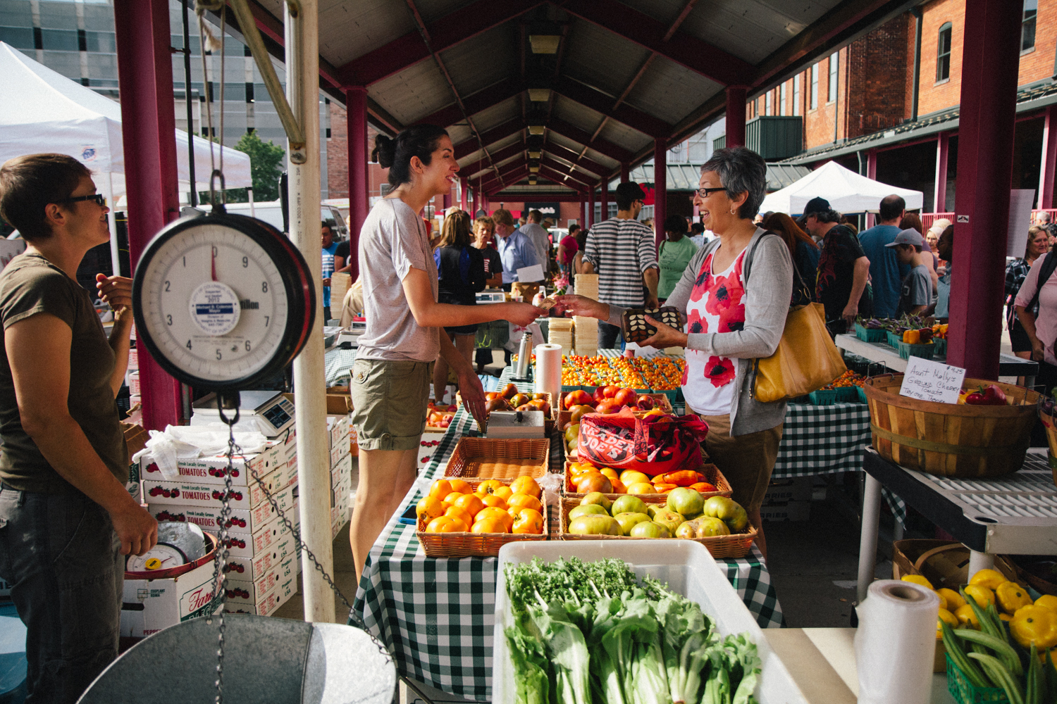
Photo from Wikimedia Commons, licensed under CC BY-SA 4.0

The Role of Policy and Collaboration
Individual choices are powerful, but they must be matched with systemic support. This is where policy and collaborative initiatives step in. EU frameworks such as the Circular Economy Action Plan or the upcoming PPWR set the rules of the game, making it easier for responsible businesses to thrive and harder for laggards to hide behind loopholes.
But regulation needs real-world testing grounds. That’s where the MAGNO project plays a critical role. MAGNO is more than a pilot; it is a platform where businesses, policymakers, and communities work together to trial reusable packaging systems at scale. For businesses, engaging with MAGNO means access to shared infrastructure, data, and expertise that lower the risks of adopting new models. It turns theory into practice and shows that sustainable packaging can be both commercially viable and widely accepted by consumers.
For policymakers, MAGNO offers evidence on what works, helping to design smarter EU-wide standards. For communities, it delivers tangible benefits: less waste, cleaner environments, and accessible alternatives to single-use culture.

Long story short: Do business but not at the costs of citizens well being.
Supporting sustainable businesses is not about rewarding “good behavior” with a pat on the back. It is about shaping the economy of tomorrow—one where responsibility is the norm, not the niche. Every purchase, recommendation, and question builds momentum toward a system where businesses don’t just minimize harm but actively contribute to thriving societies and ecosystems.
Consumers are not powerless spectators—we are partners in shaping the future. By backing businesses that embrace responsibility, and by encouraging initiatives like MAGNO that give companies practical pathways to change, we accelerate Europe’s transition toward a sustainable economy that benefits everyone.
Good business truly can mean a better world.

