Apps and Tools to Track Your Waste Reduction Efforts: Making Waste Reduction Accessible Through Technology
For many people, the intention to reduce waste is already there. They bring reusable bags, try to avoid unnecessary packaging, or make small changes at home. And yet, after a while, a familiar feeling appears: Is this actually making a difference?
Waste reduction often feels invisible. Progress is slow, scattered across small decisions, and difficult to measure. Without feedback, motivation fades.
This is where digital tools can help. Not by demanding perfection, but by making effort visible.

Technology as support, not control
One of the biggest challenges of waste reduction is that success often looks like nothing is happening. Less waste means fewer items, fewer bins filled, fewer bags thrown away.
Tracking tools can help visualise these “non-events”. They can show how often reusable items are used, how habits evolve over time, or how small changes accumulate. Seeing this progress, even approximately, helps people stay engaged.
Also, for many consumers, waste reduction feels complex. What counts? Where do you start? How do you know if you are doing it right?
Simple apps and tools can lower this barrier by breaking change into manageable steps. Instead of focusing on everything at once, they allow users to start small: tracking one habit, one type of waste, or one daily choice.
This makes sustainability feel accessible rather than overwhelming.

Examples of existing apps and tools for waste reduction
There is no single app that can solve waste reduction on its own. However, different tools show how technology can support awareness, motivation and everyday action in complementary ways.
- My Little Plastic Footprint (WWF)
Developed by the World Wide Fund for Nature, this app helps users reflect on how plastic fits into their daily routines. Rather than tracking every single item, it uses challenges and practical suggestions to make plastic reduction feel achievable and encouraging, not overwhelming.

- AWorld (UN ActNow)
Promoted by the United Nations, AWorld allows users to track everyday actions, including waste related behaviours. It focuses on positive reinforcement and awareness, connecting individual actions to global sustainability goals without relying on guilt or pressure.

- OLIO
OLIO is a community-based app that helps people share the things you no longer need instead of throwing it away. By connecting neighbours, shops and volunteers, it turns potential waste into a shared resource. It also contributes to reducing unnecessary packaging and highlights the social dimension of waste reduction.

- Recycle Coach
One of the most common barriers to proper waste management is simply knowing what goes where. Recycle Coach provides clear, localised information on how to sort waste correctly. Its search function helps users quickly determine how specific items should be disposed of, reducing confusion and improving recycling quality.
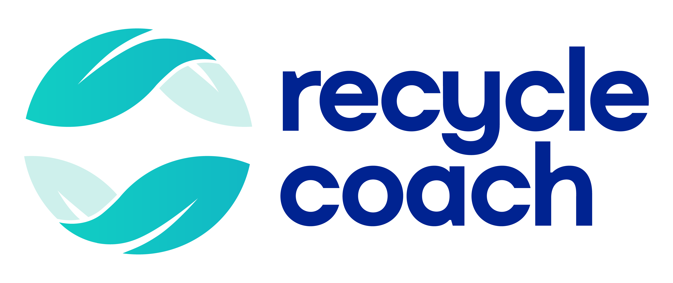
- Refill
Refill focuses on reducing single-use bottles and cups by helping users locate places where they can refill water bottles for free or receive discounts for bringing reusable cups or lunchboxes. The app shows how digital tools can support reuse by making sustainable infrastructure more visible.
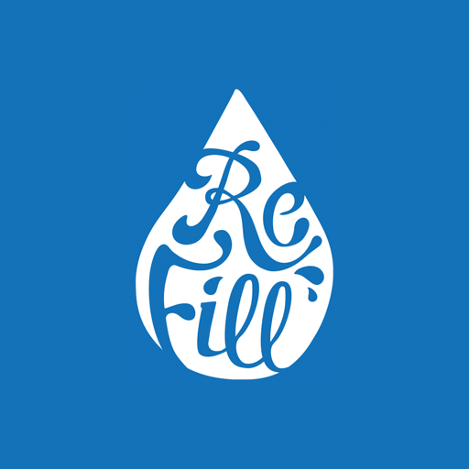
- Too Good To Go
Too Good To Go connects users with surplus food from shops and restaurants that would otherwise be discarded. Beyond preventing food waste, it helps make waste visible and tangible, showing how much perfectly good product is lost and how easily that can be avoided.

- Ailuna
Ailuna supports users in building sustainable habits, including waste reduction. It allows users to set goals, track progress and receive tips related to zero-waste lifestyles. While broader in scope, it can be useful for people who prefer a single app to reflect on multiple sustainability habits.


Together, these tools illustrate different ways technology can support waste reduction: by encouraging reflection, clarifying systems, enabling reuse and making progress visible.

From individual habits to collective awareness
Digital tools can also help people see how individual actions connect to broader systems. Some apps link personal habits to collective data, community initiatives or global goals, reinforcing the idea that waste reduction is not only an individual responsibility. In shared contexts, such as households, schools or communities, technology can support cooperation rather than comparison.
Apps and tools do not reduce waste on their own. They support reflection, learning and motivation, but real change happens through habits, systems and collective choices. And when used thoughtfully, technology becomes a companion rather than a driver. It helps people notice their progress, understand their impact and stay engaged over time.
In a world where waste reduction often feels abstract, digital tools can help turn intention into awareness, and awareness into sustained action.

